**PhonePe Internship**

**Data Science**

**Week 1**

Basic understanding after first interaction. Custom UX for each user. Creation of canvas on PhonePe home screen with respect to user liking. Three stages:

1. Creation of caricature of the person → Need person-cartoon pairs. Need user to provide image also. Either use existing dataset. Zero-shot learning? Pretrained models:
   * <https://github.com/happy-jihye/Cartoon-StyleGAN>
   * <https://github.com/justinpinkney/toonify>
2. Style transfer of font →
   * Expensive items: CLASSIC font.
   * Items related to like childcare: QUIRKY font.
   * Interpolation between two extremes. Use custom cGAN to generate and fonts and then interpolate.
   * Or pretrained model: (<https://arxiv.org/abs/2108.12965>, <https://github.com/VITA-Group/Font_Completion_Graph>):

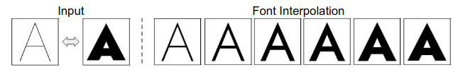

1. Gradient colors → Color the banner w.r.t. to these colors that the user likes. Need some way to get user input on favorite color.

Better understanding of the project. Currently need to focus only on the first 2 stages.

Stage 1: Many users have their profile picture set up. In the future, can ask for picture for better UX. Need to create a caricature from the image so as to display on important banners in the app. Various models can be used:

* WarpGAN (<https://github.com/seasonSH/WarpGAN>): The final warped images are quite pleasing. We also can choose which variation of WarpGAN to use (from 1, 2, or 3) according to suitability with 1 being the most preferable. Can also customize the exaggeration level with the “scale” parameter. Written in TF1.9. Pretrained model available. Quite fast in generating images.

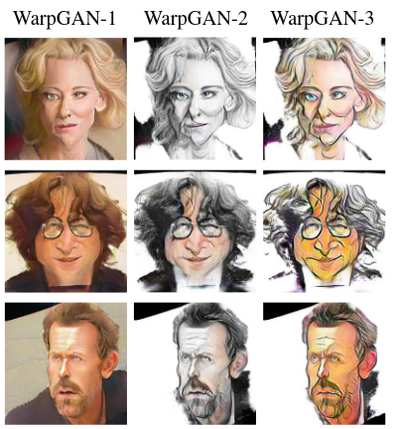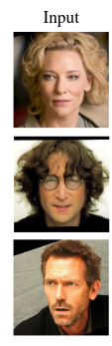

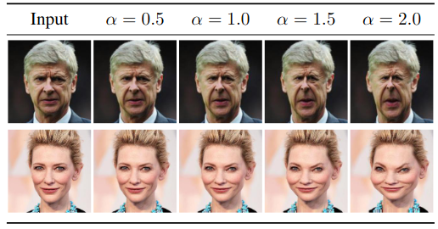

My results:

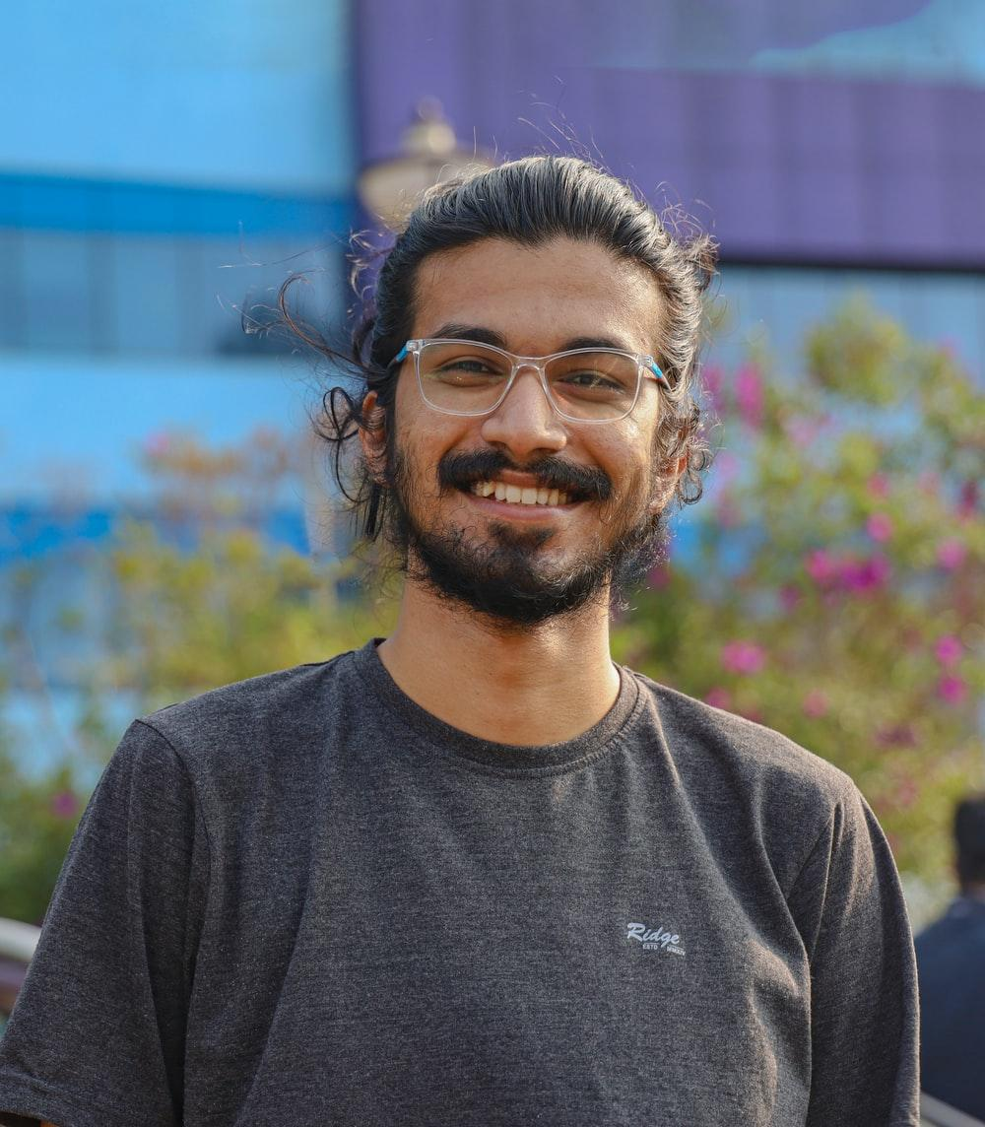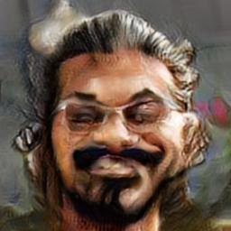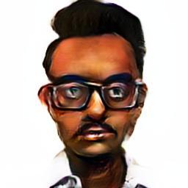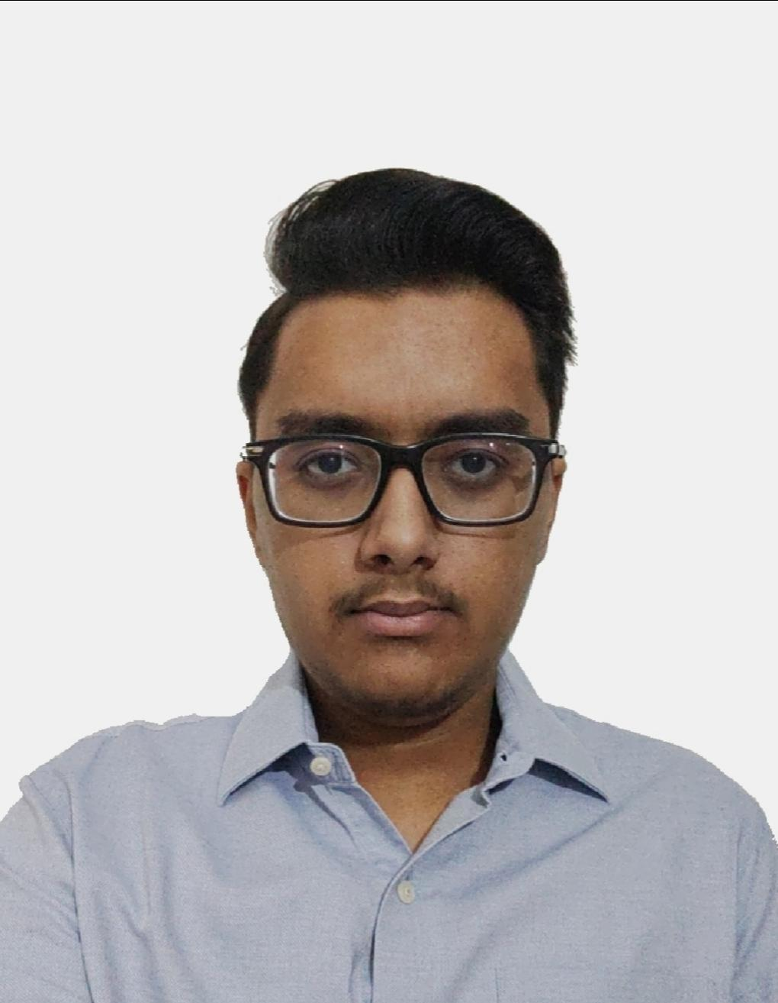

* CariGAN (<https://cari-gan.github.io/>): The end result is not what a customer should see because he / she might get offended as most of the times the model produces photos which are ugly looking as shown below. Also, the source code is unavailable.

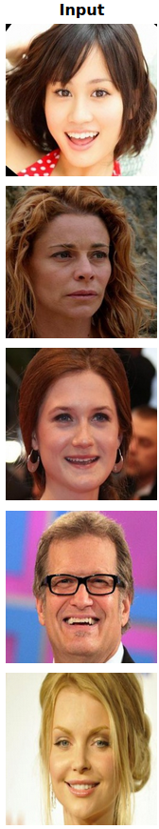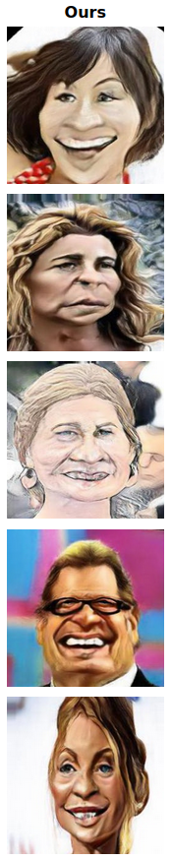

* StyleCariGAN (<https://github.com/wonjongg/StyleCariGAN>): Written in PyTorch. Better than the vanilla CariGAN in the sense that the generated photos look more cartoonish and are not ugly at all. Requires GPU to train as well as test.

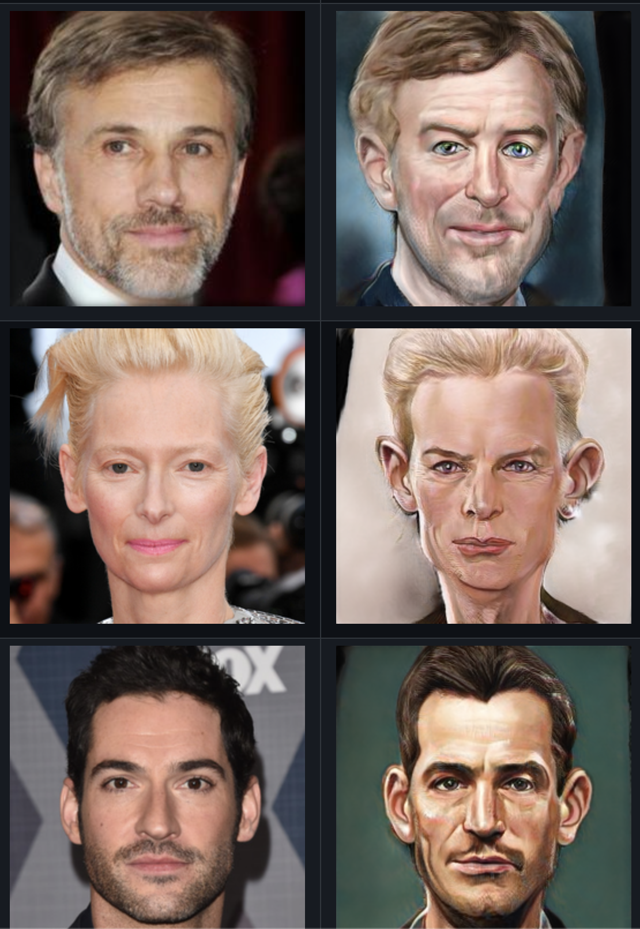

* Toonify (<https://justinpinkney.github.io/toonify-api-docs/models/#toonify>)

Gives quite good result but takes a lot of time per image which may be a hindrance.

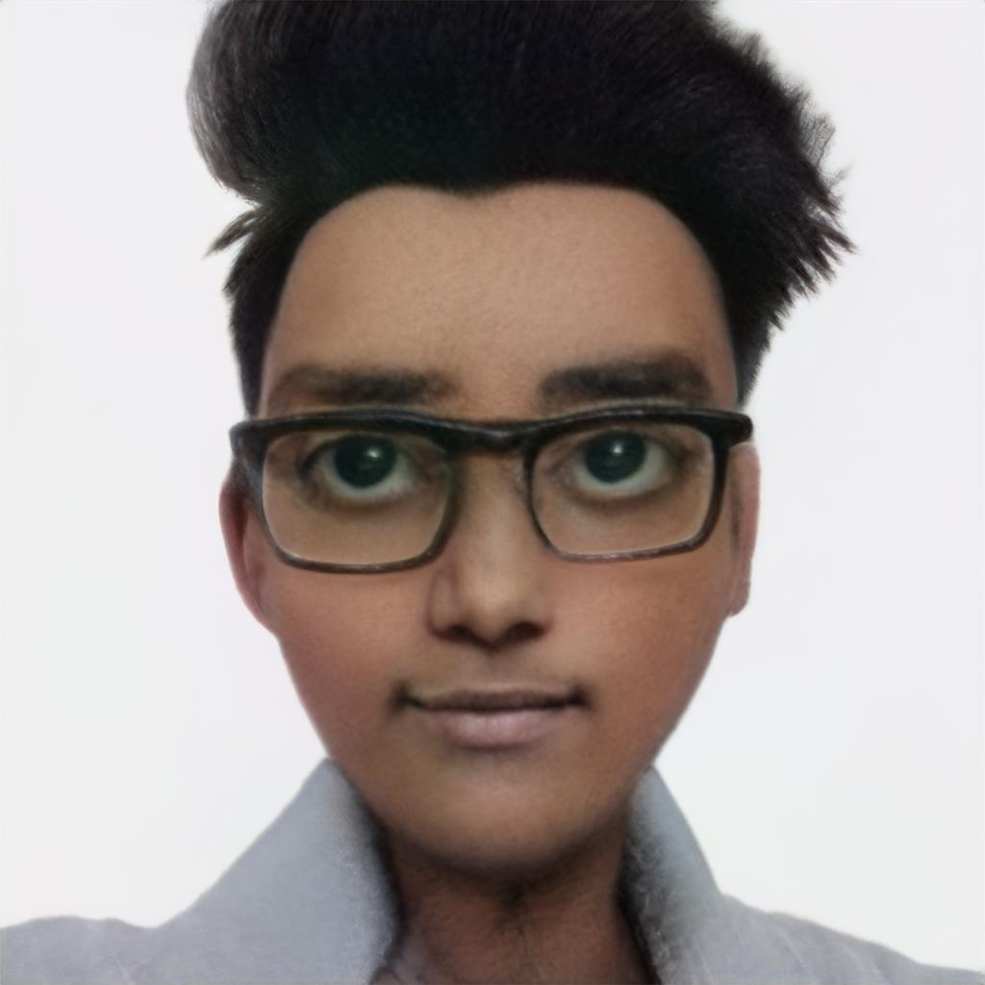

* WhiteBoxCartoonization (<https://github.com/SystemErrorWang/White-box-Cartoonization>, Demo: <https://app-guest.sciencedesk.net/#/algorithms/15/run>):

Need to detect face first if required. Results are consistent and pleasing. Fast in generation.

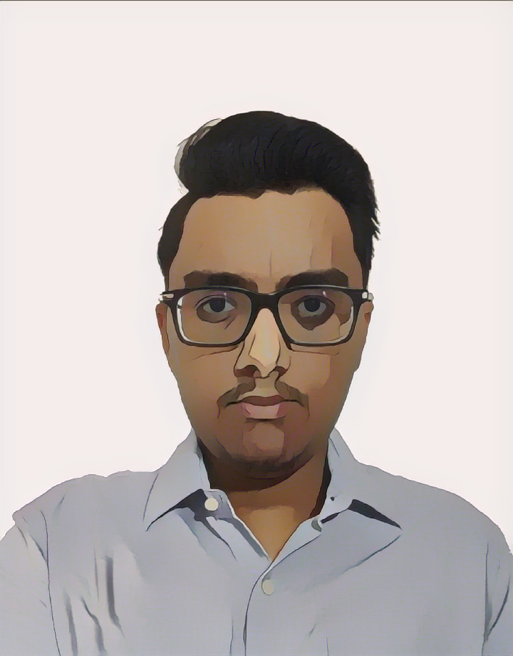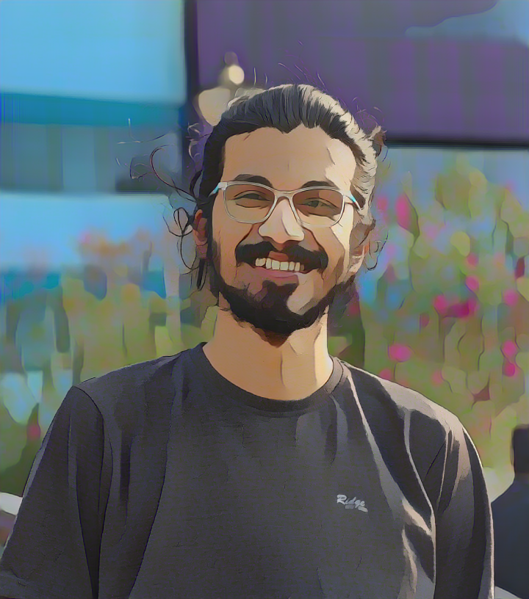

* JoJoGAN (<https://github.com/mchong6/JoJoGAN>, Demo: <https://huggingface.co/spaces/akha>[liq/JoJoGAN](https://huggingface.co/spaces/akhaliq/JoJoGAN)): Written in PyTorch. Gives high quality artistic images. Now, accordingly we have to decide whether to go for a more cartoonish feel or a little more mature one.

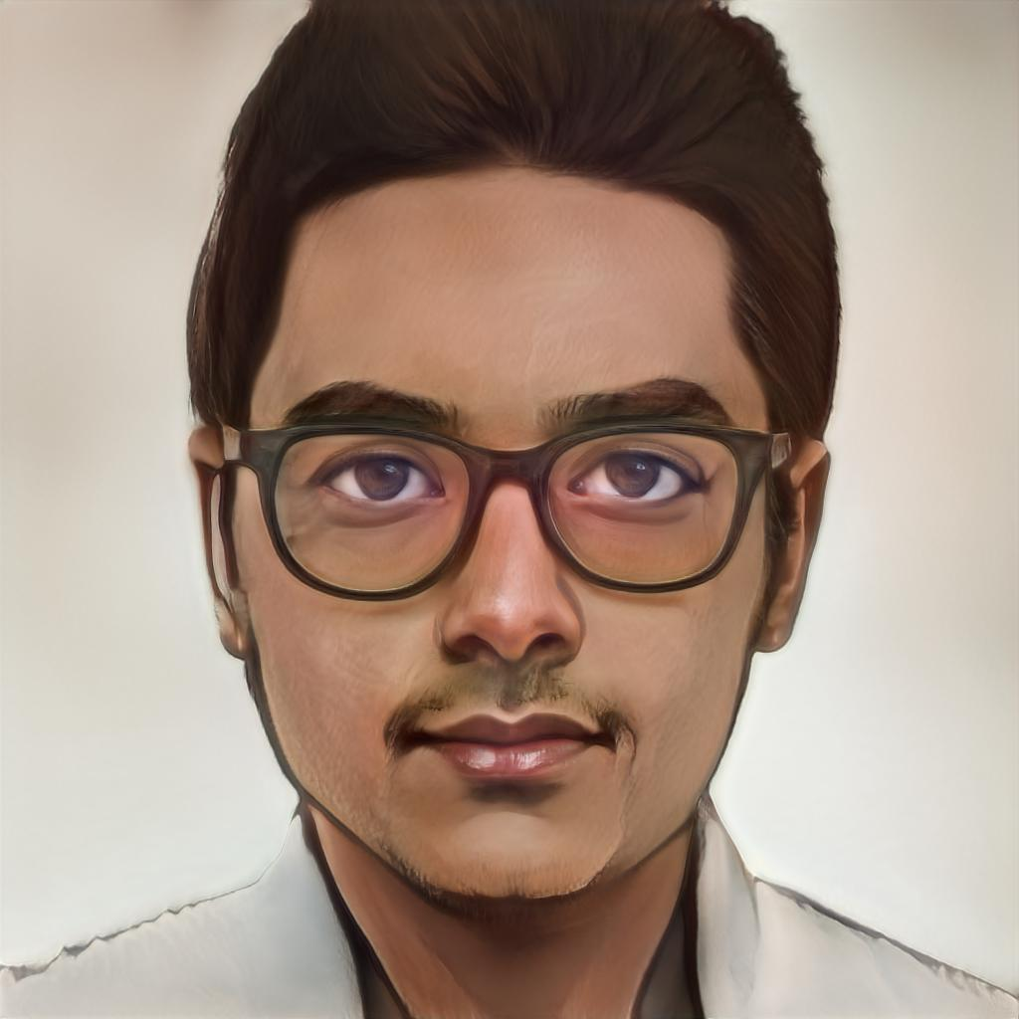



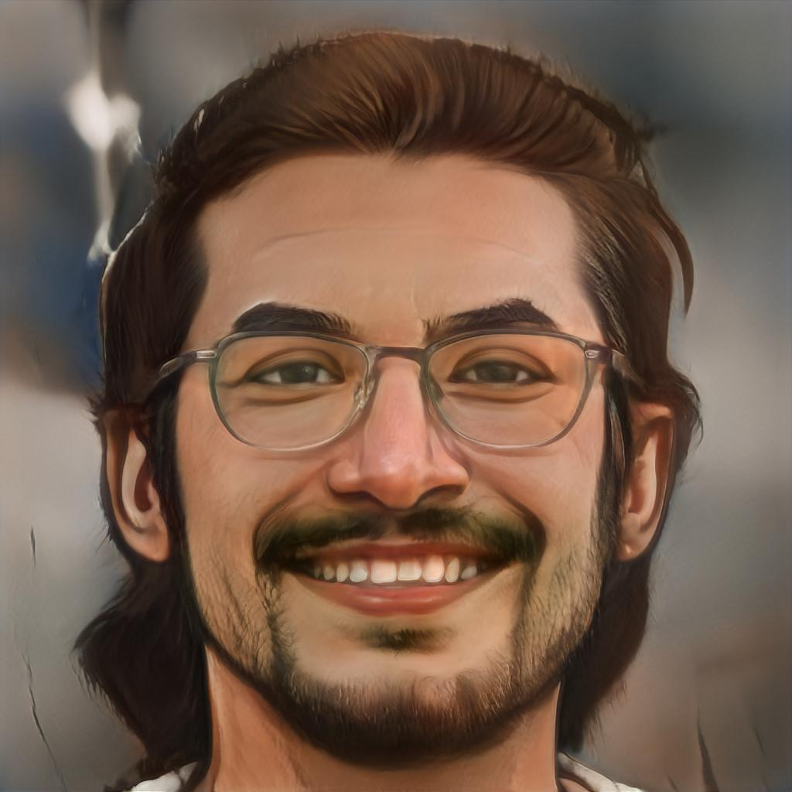

Stage 2: Font generation from a generated set of creatives. For example, loans may have a specific creative attached with them and that would be shown to the user in the app. Designing costs are saved.

Website for font pictures: <https://www6.flamingtext.com/All-Logos/>

Two similar models which can be used:

* MC-GAN (<https://bair.berkeley.edu/blog/2018/03/13/mcgan/>, <https://github.com/azadis/MC-GAN>): Written in PyTorch. Need to manually select font images according to use case and then generate. Need to port to TF or vice-versa if necessary. Dataset, model link is broken. Find other alternatives.

* AGIS-NET (<https://yuegao.me/AGIS-Net/>, <https://github.com/hologerry/AGIS-Net>): Also written in PyTorch. Performs better than MC-GAN according to sources. Requires GPU to train. First pretrained on a number of glyphs / styles. Then fined-tuned on one specific glyph which we want to generate. Pretrained model not available. Need to manually train and test.

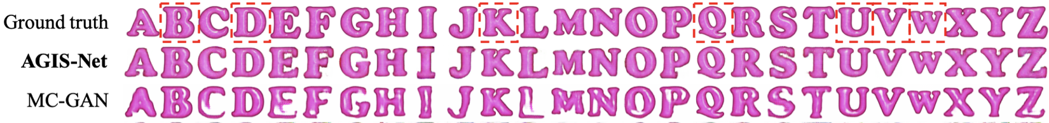

Stage 3: Just like DALL-E. For example, if we sent a push notification to user regarding bike insurance, then we can attach a picture of the user sitting on a bike with appropriate color scheme in that notification. UX is way better this way. This stage is also quite challenging.

Queries:

* If we give the GAN a font to generate then why not use the same font by downloading? Maybe because the font itself is just a picture from a creative?
* How are Stage 1 and Stage 2 connected?

**Week 2**

Stage 1:

Two models finalized based on results – StyleCariGAN and JoJoGAN. Need to look deeper into which dataset is used, what is its size and how it is used. Read research paper.

* JoJoGAN ← StyleGAN ← ProGAN
* ProGAN: <https://towardsdatascience.com/progan-how-nvidia-generated-images-of-unprecedented-quality-51c98ec2cbd2>
* StyleGAN: <https://towardsdatascience.com/explained-a-style-based-generator-architecture-for-gans-generating-and-tuning-realistic-6cb2be0f431>
* GAN inversion: <https://sertiscorp.medium.com/gan-inversion-a-brief-walkthrough-part-i-bc2ee1b73253>
* A very nice article on GANs: <https://towardsdatascience.com/keywords-to-know-before-you-start-reading-papers-on-gans-8a08a665b40c>

JoJoGAN:

* One-shot learning.
* StyleGAN’s style-mixing property and GAN inversion are used to generate a paired dataset which is then fine tuned on StyleGAN.
* It is a general model – not only for faces. Allows user to control how much style to transfer (by controlling interpolation between StyleGAN and JoJoGAN) and what aspects of the style are transferred (by controlling the parameter *M*).
* Style mapper obtained in under 60s i.e. fine tuning time on GPU.
* The steps are as shown below:
  1. Use GAN inversion to obtain the *s-code* for ref image.
  2. Using this *s-code*, generate new *s-codes* that are “close” to this one. *M* parameter’s importance i.e. style mixing.
  3. Loss between the ref image and StyleGAN generated images (from the generated *s-codes*) is minimized.
  4. Inference using a new test image.

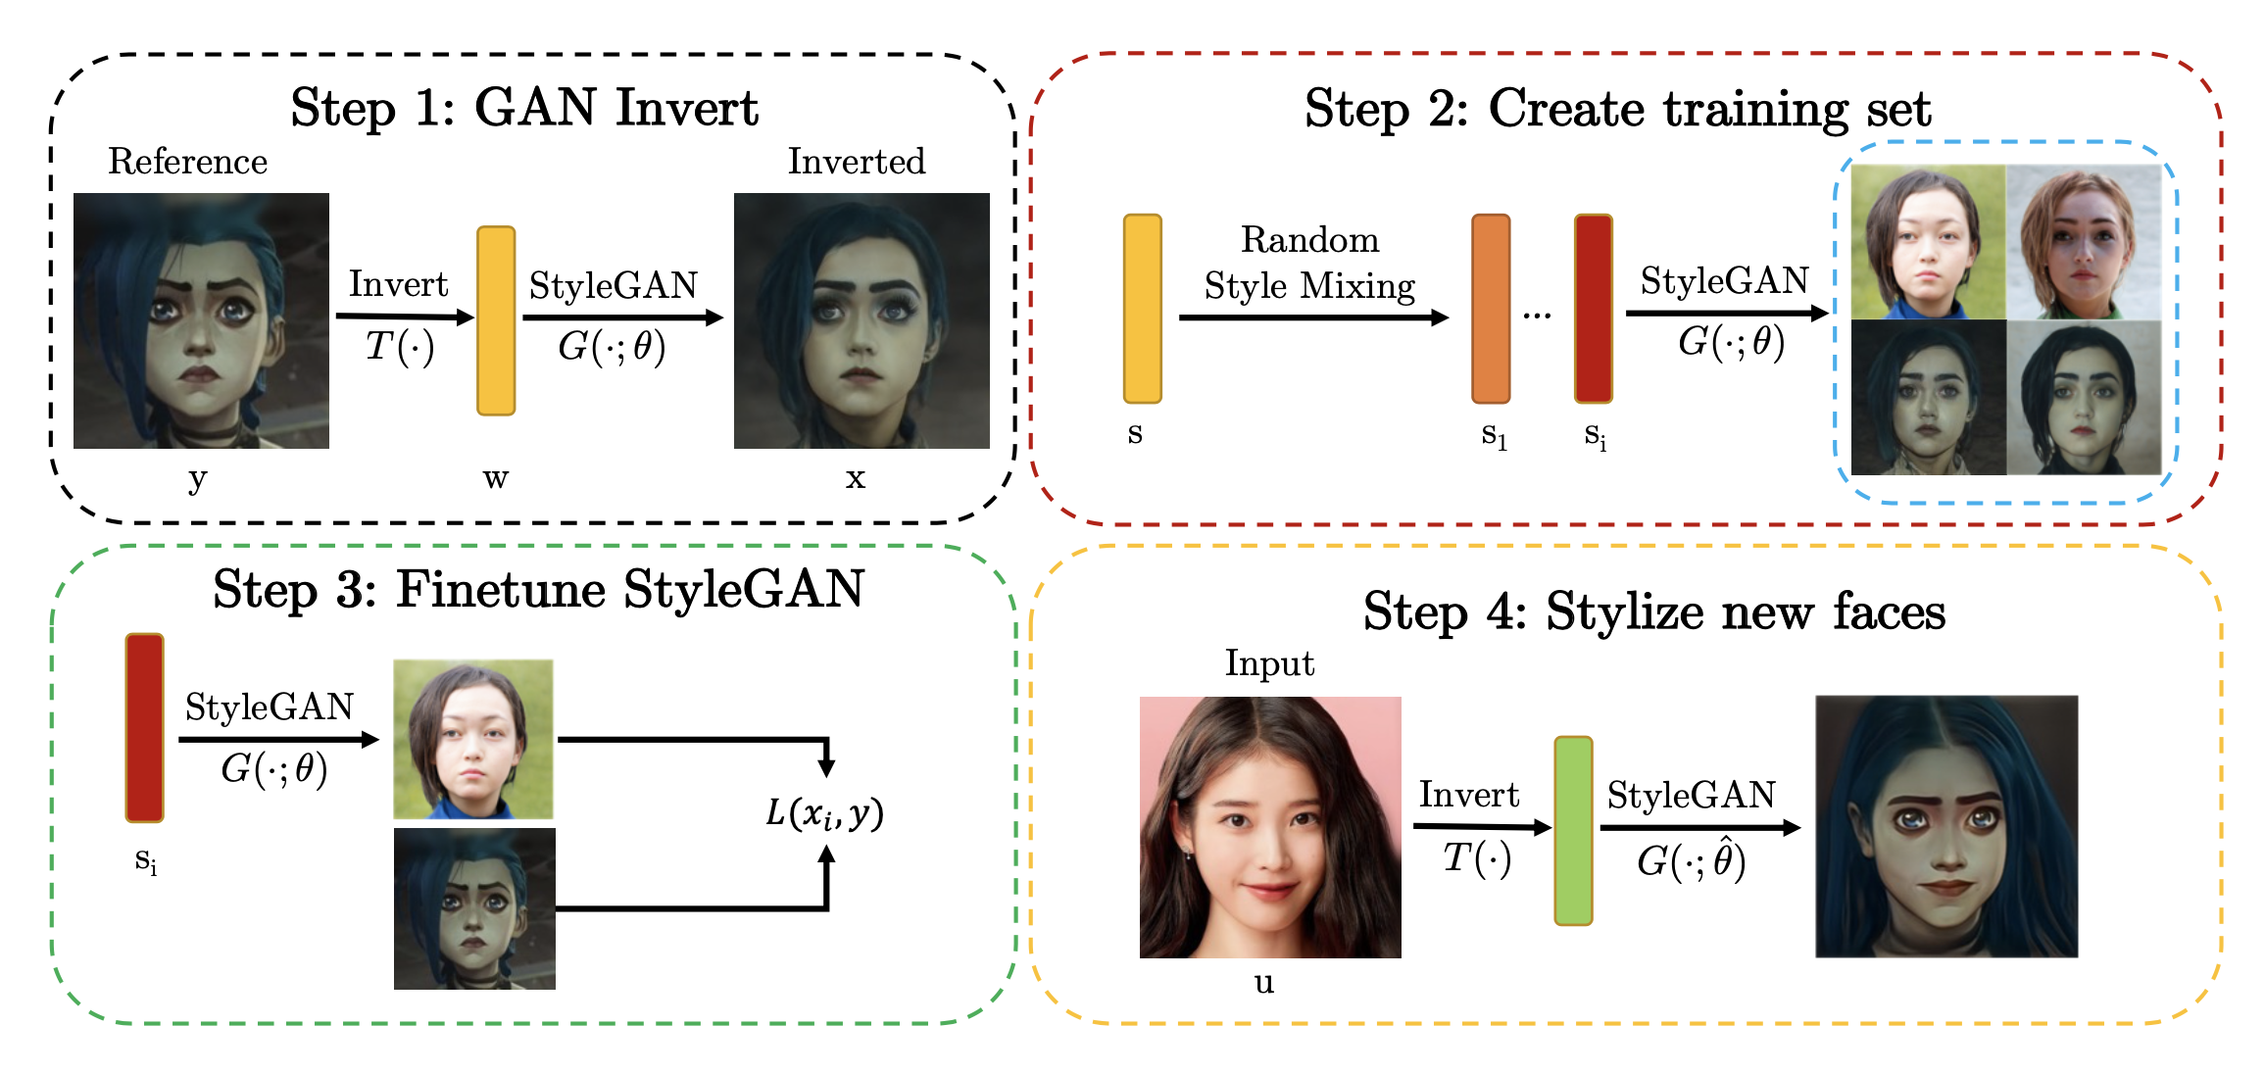

Stage 2:

AGISNet (Artistic Glyph Image Synthesis) finalized. Also look deeper into the code and understand the working. Read research paper as well. Read research paper.

* Pix2Pix GAN: <https://towardsdatascience.com/pix2pix-869c17900998>

AGISNet:

* Dataset: the English glyph image dataset – 32046 synthetic artistic fonts, each with 26 glyphs for pre-training. For fine-tuning (few-shot learning), dataset containing 35 professional-designed English fonts with special text effects used.

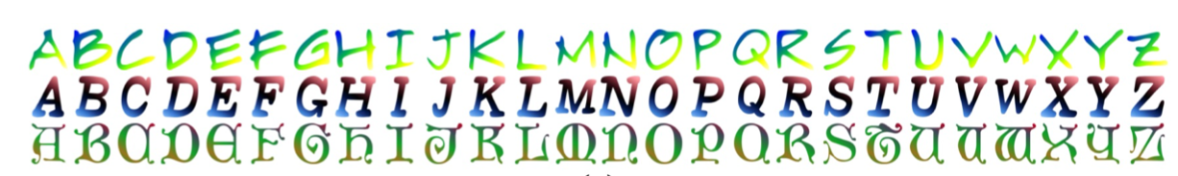

* Only for capital alphabets as the datasets contain capital letters only. May use for small alphabets but results are unsatisfactory.

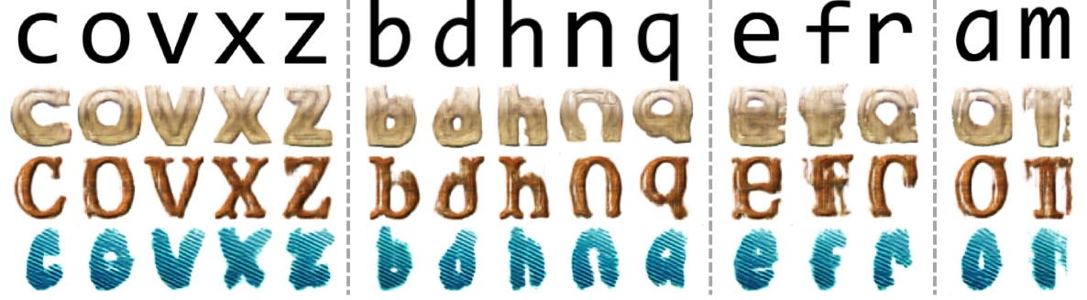

* Generator: 2 encoders used – one for content, one for style. 2 decoders also used – one to extract shape, one for texture. Skip connections as in Pix2Pix’s U-Net are used.
* Discriminator: 3 discriminators used – Dshape, Dtexture and Dlocal. All three resemble PatchGAN in Pix2Pix.

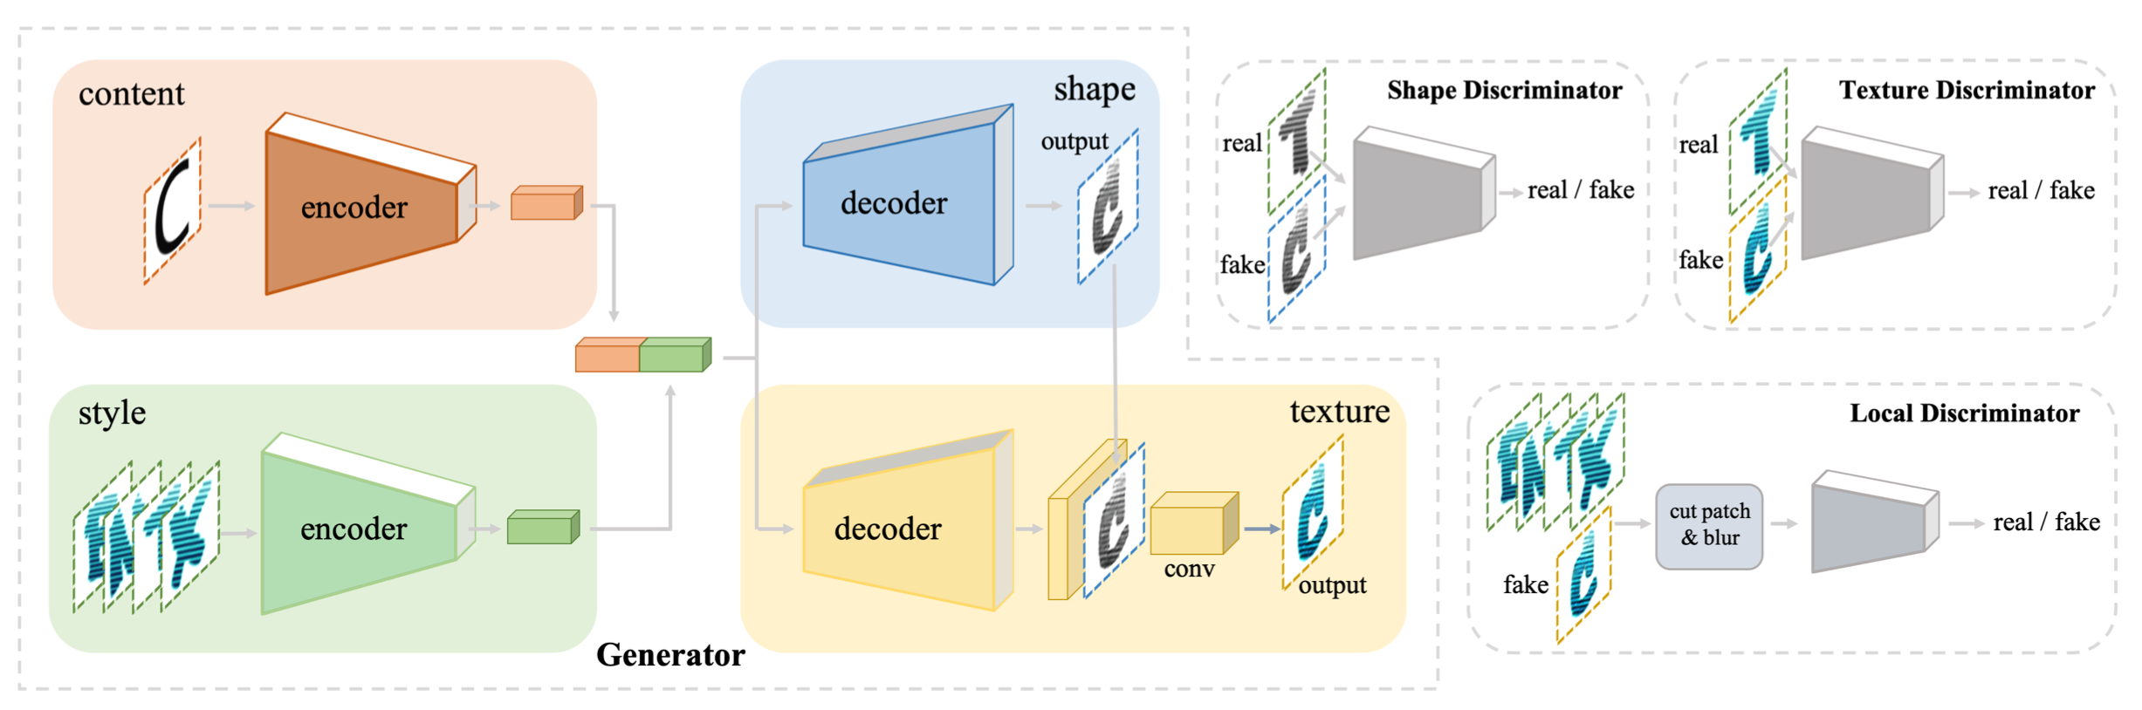

* Pretrain on the entire dataset. Fine-tune (few-shot learning) on the specific style.

Important points:

* Stage 1 and Stage 2 are currently independent components but would be connected in future. Suppose we have a custom font and custom user image (both generated). Then we need to generate a creative composed of these two with an additional positional layer which would determine the appropriate positioning of these two together. Something like HouseGAN (<https://github.com/ennauata/housegan>).
* Currently, dataset is assumed to be present and we only need to focus on reproducing the results. After that, we need to build a custom dataset by retrieving premium fonts for premium creatives from the web and so on.

Current focus: Stage 1

* Look into the codebase. Understand the loss functions. Modify the code to make a flexible model for our use case. Try to reproduce results for a specific use case, for example, RK Laxman cartoon faces:

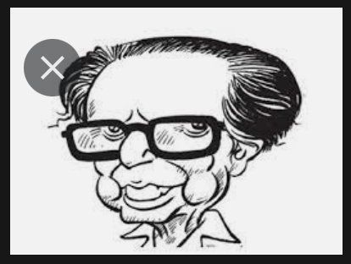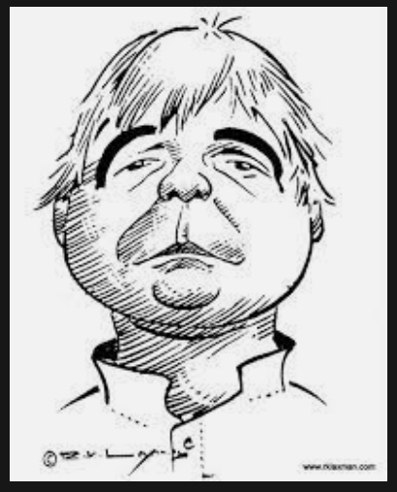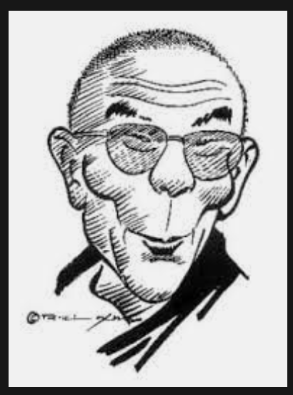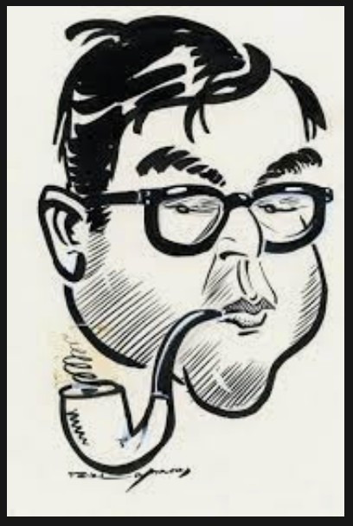

* Instead of using common loss functions for faces like LPIPS, StyleGAN’s discriminator is used. Discriminator features are known to stabilize GAN training when averaged over batches. So, the loss is chosen as the difference in discriminator activations at particular layers, per image:



* StyleGAN2 is used and instead of the official implementation, a better implementation that improves the image quality is used (<https://github.com/rosinality/stylegan2-pytorch>).
* One inconsistency noticed in the paper – In GAN inversion, it is written that *ReStyle* is used which seemed to give better results than *e4e* but in the code *e4e* is used. Modification: Can try to use *ReStyle* if necessary. Update: This issue has already been raised on Github (<https://github.com/mchong6/JoJoGAN/issues/30>). Hence, the final results might even be better than what we were getting.
* Update regarding the number of training pairs from code: 1 generated training pair per iteration (batch size = 1) for 300 steps.
* We can also multi-shot learning if we need to i.e. combine 2 or more styles.
* Convert *ipynb* to *py:* ✅
* Converted notebook code to 3 modular python scripts – one for downloading data, one for generating images from a pretrained model and one for generating images by fine-tuning the generator first.
* Read the *e4e* *(encoder4editing)* and *ReStyle* paper. Not necessary but recommended: ✅
* Look in the code to experiment which changes affect which areas of the face.
* Create a PPT for explaining how the model works in basic words and explain which changes affect which areas of the face and how.
* In the paper 26 style modulation layers are chosen, but in the code it is 18.
* Controlling Style Intensity by Feature Interpolation: Vary the intensity of style. Continuous face stylization using

*f = (1 − α) * fiA + α * fiB*

where *fiA* is the layeri intermediate feature maps from the original StyleGAN and *fiB* from JoJoGAN. This is style mixing and is controlled by *alpha* in the code.

* Controlling Aspects of Style: Simple control is obtained by choice of mask. More detailed control follows by careful attention to the GAN inversion.
  + Controlling Aspects of Style by Mask Choice: replacing too many elements of *s* with random numbers may result in a JoJoGAN that maps every face to the style reference; replacing too few means fine-tuning sees too few examples. Replacing elements at locations corresponding to different StyleGAN layers controls different effects. In the code *id_swap* actually does the work of *M* (mask).
  + Control by Manipulating GAN Inversion: if the GAN inverter produces an extremely realistic face from the reference, JoJoGAN will tend to produce aggressively stylized faces. If the GAN inverter produces a somewhat stylized face from the reference, JoJoGAN will tend to produce lightly stylized faces and to preserve the features of the input face. Try GAN inverter blending – blend mean code with original inverter to get control over whether the eyes, mouth, nose should be more like input or the reference.
* One common issue JoJoGAN has is that the eye gaze direction is often driven by the reference image rather than the input. This shouldn’t be much of a problem though.
* An issue has been raised for queries regarding the model in the source repo: <https://github.com/mchong6/JoJoGAN/issues/34>. Queries resolved: ✅
* Try identity loss to fix photos which are distorted:

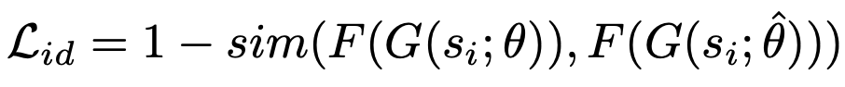

where *sim* is cosine similarity and *F* is a pretrained face embedding network (like ArcFace)

**Week 3**

Tasks needed to be done:

1. Integrate *ReStyle* GAN inverter in the code: ✅

Comparison between e4e and ReStyle:

* + e4e: 16s. Results unsatisfactory and differ from the original image. We can see that the skin color, hairstyle, facial expression, eyes and even spectacles do not match.

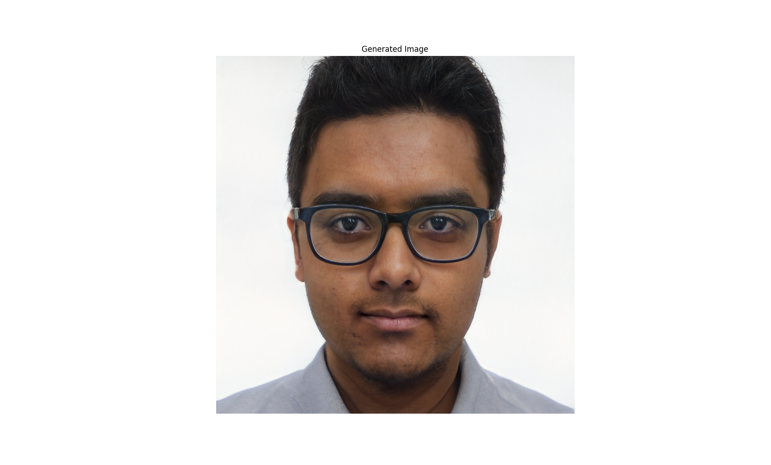

* + ReStyle: 40s for 5 iterations i.e. 8s per iteration. For best results 5 iterations are sufficient. So, there is a trade-off for between speed and quality. Time taken for ReStyle is 2.5 times greater. This overheads only accounts for during inference. Not during training. Could try with lower iteration values.

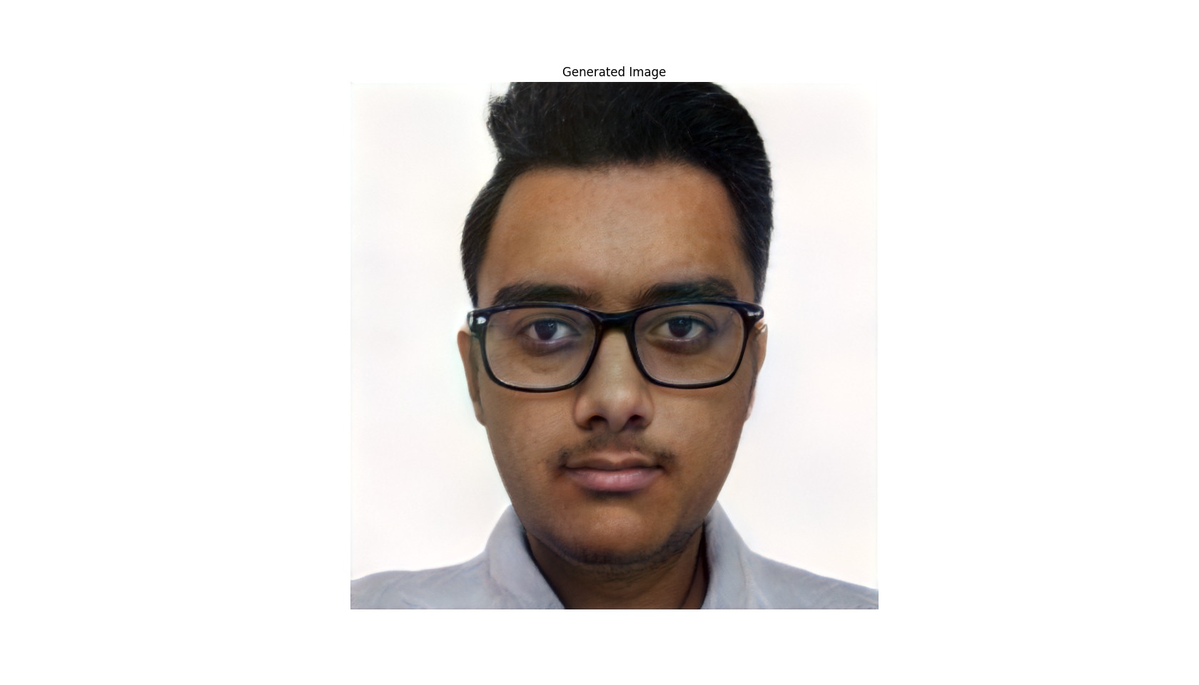

1. Look into *RetrieveInStyle* (*RIS*, <https://github.com/mchong6/RetrieveInStyle>) and check if it fits our use case: ✅
2. Use the updated code in Colab to generate results for the new styles: ✅
3. Find good caricature pictures which translate well to our use case and try experimenting with different *mask* and *alpha* values: ✅

Completed reading *Restyle* research paper. Some important points:

* It is learning-based rather than optimization-based. In theory, the reconstruction loss is a little more in the former but the inference time is around 20 times less than the latter approach.
* Here, we need to specify the *n* (number of steps) to perform gradient updates. Generally, *n = 5* is good enough for quality-time tradeoff.
* The architecture is as shown below:

An important point to note is that the encoder here can be any prebuilt encoder like *e4e* or *pSp.* The loss used is same as the one used in the prebuilt encoders (pixel-wise L2 + perceptual loss).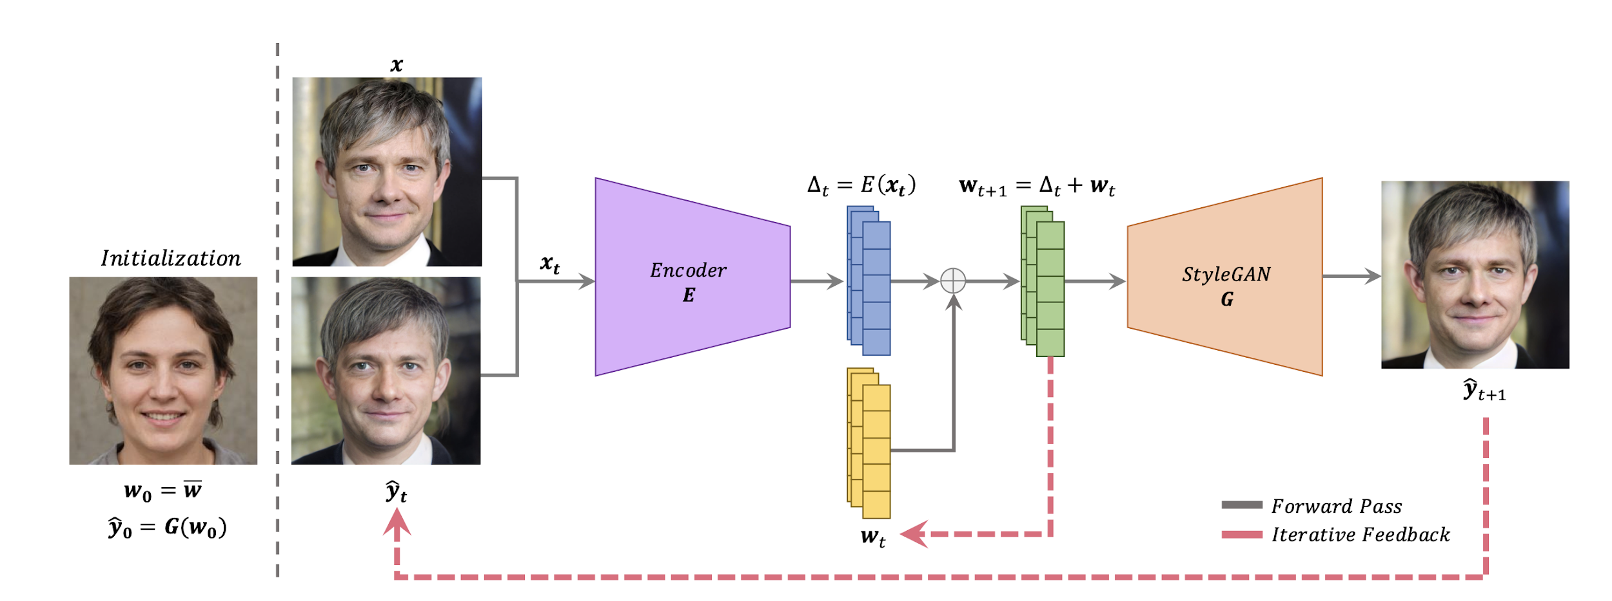

* Performance better than *e4e* with just a slight increase in inference time.
* Encoder Bootstrapping:

Rather than initializing the iterative process using the average toon image, the given real image is passed to an encoder tasked with embedding real images into the latent space of a StyleGAN trained on FFHQ. Doing so will result in an inverted code **w**1 and reconstructed image **y**1. This inverted code and reconstructed image are then taken to initialize the toonification translation using ReStyle. 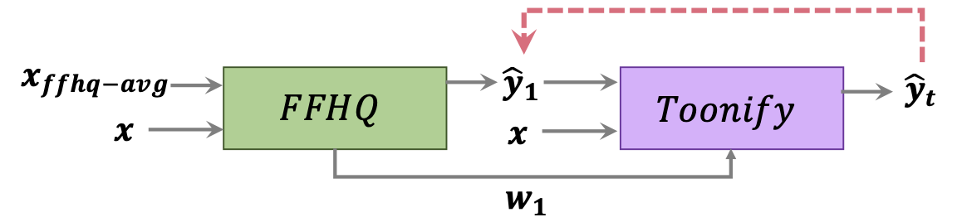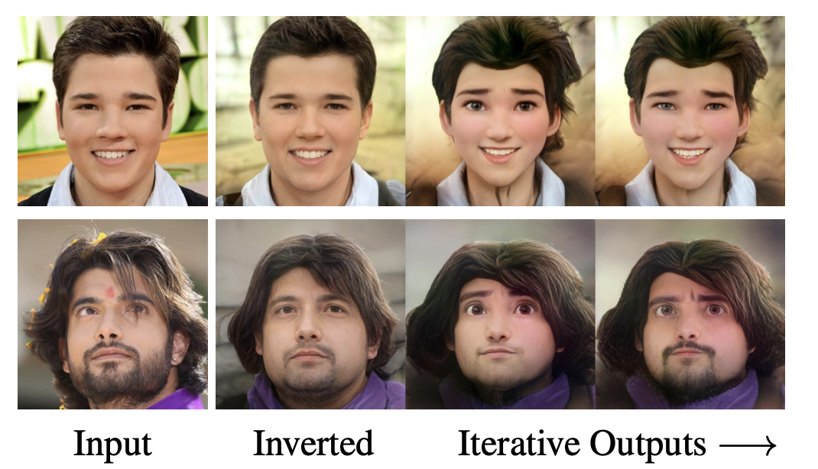

Some possible choices with different caricatures. To generate these images, optimizer hyperparamaters were tweaked, *preserve_color* was altered (although in most cases, color is preserved) and alpha values were changed. The most visually pleasing images were segregated. The GAN inverter used was *e4e* which seems to underperform than *ReStyle* as we would be seeing ahead.

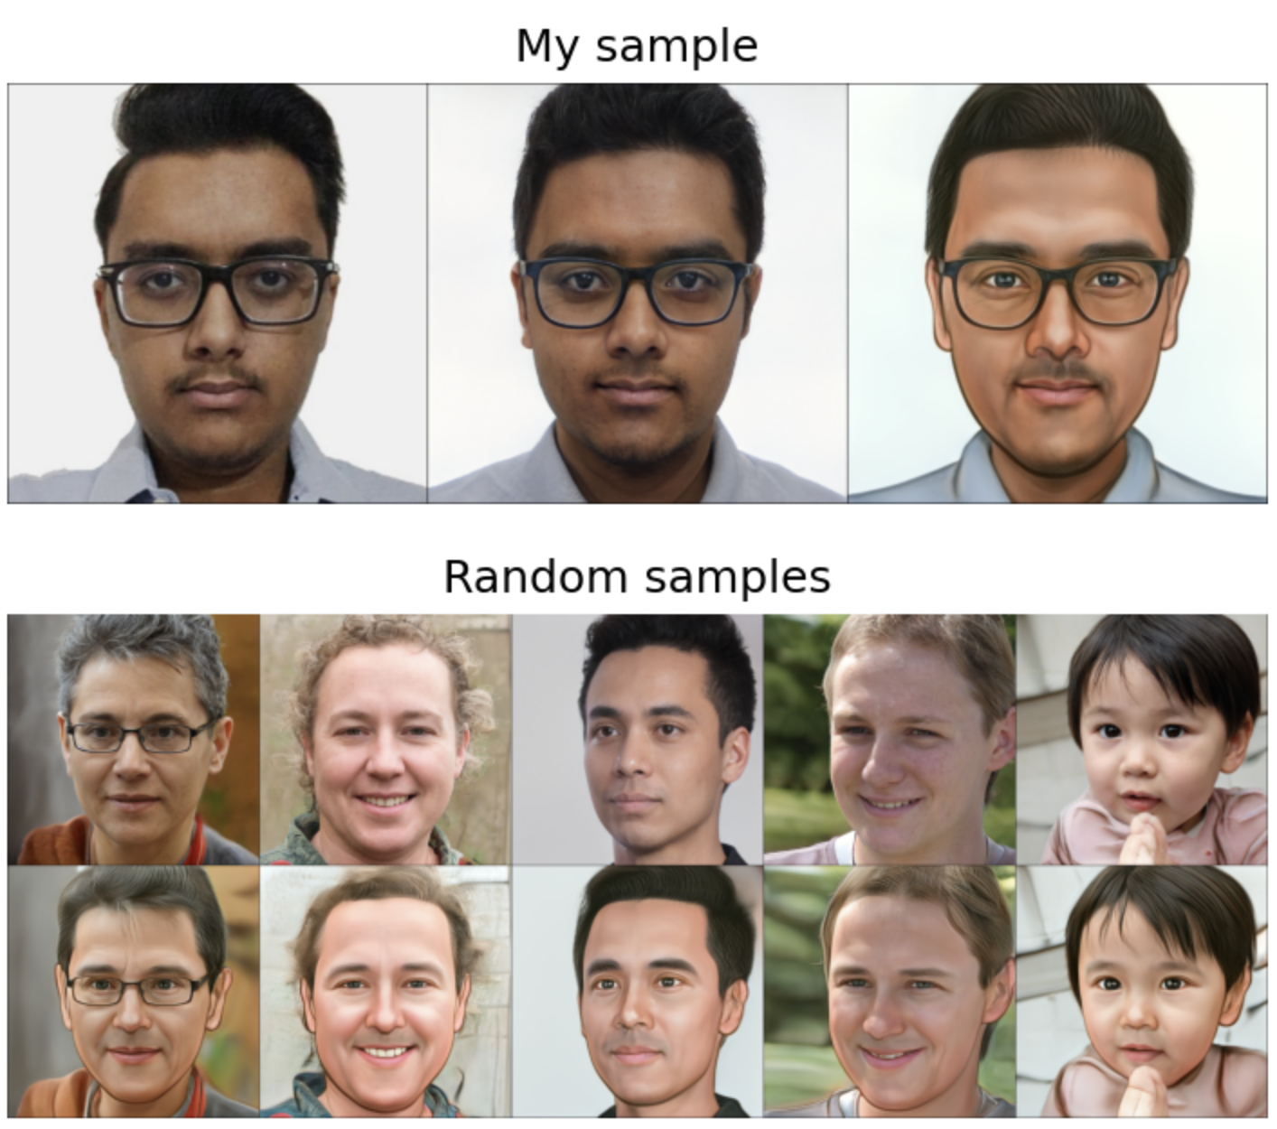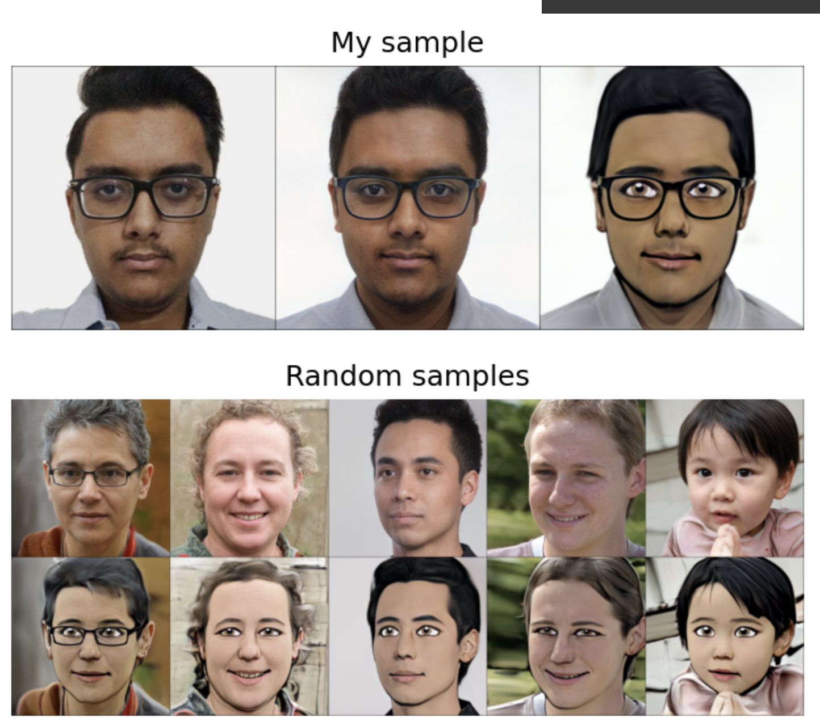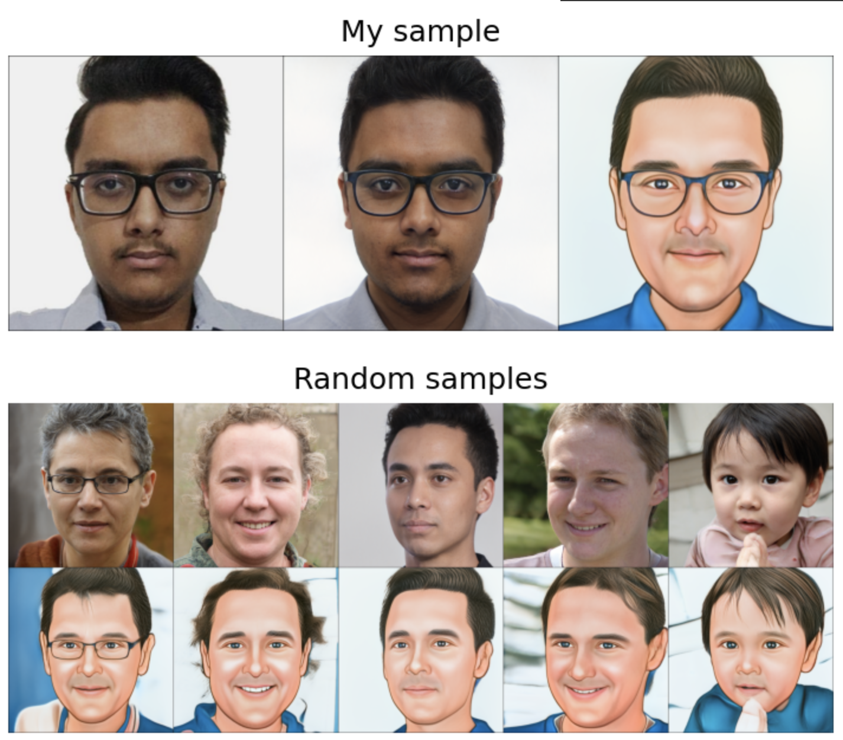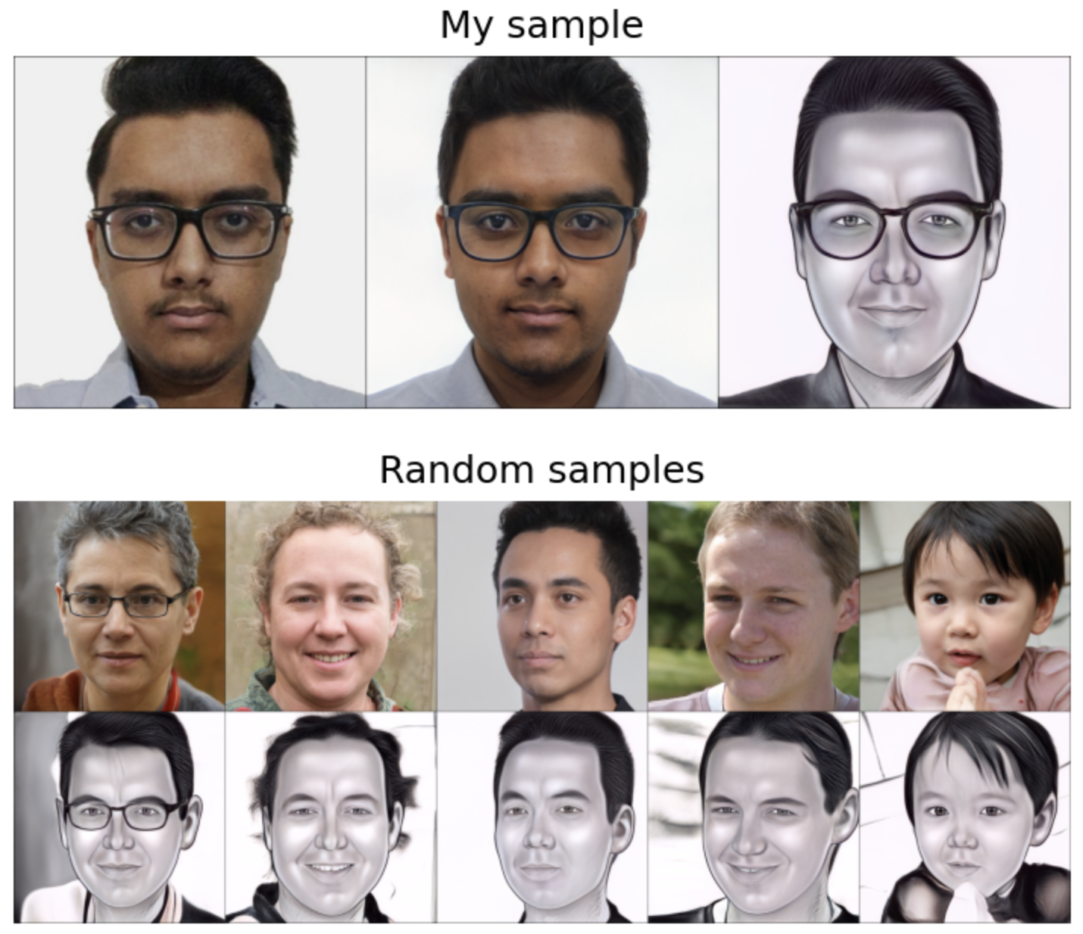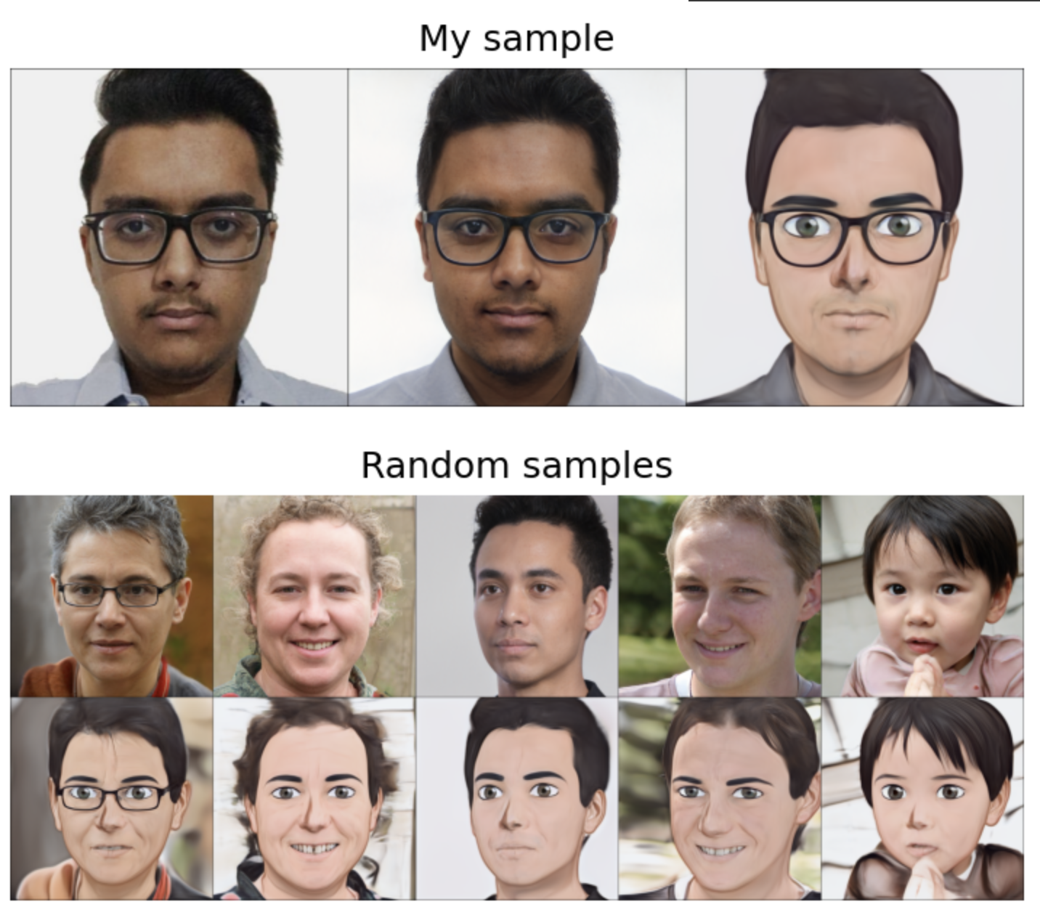

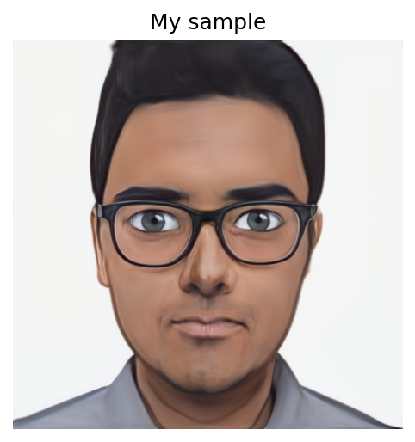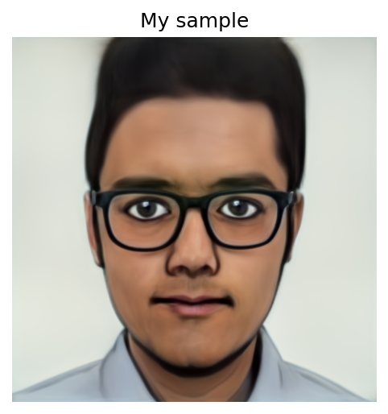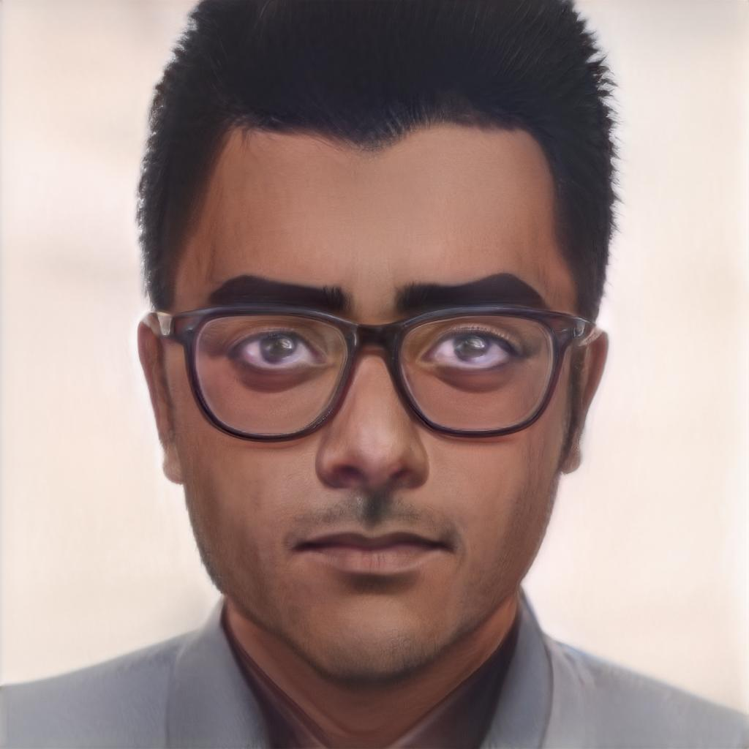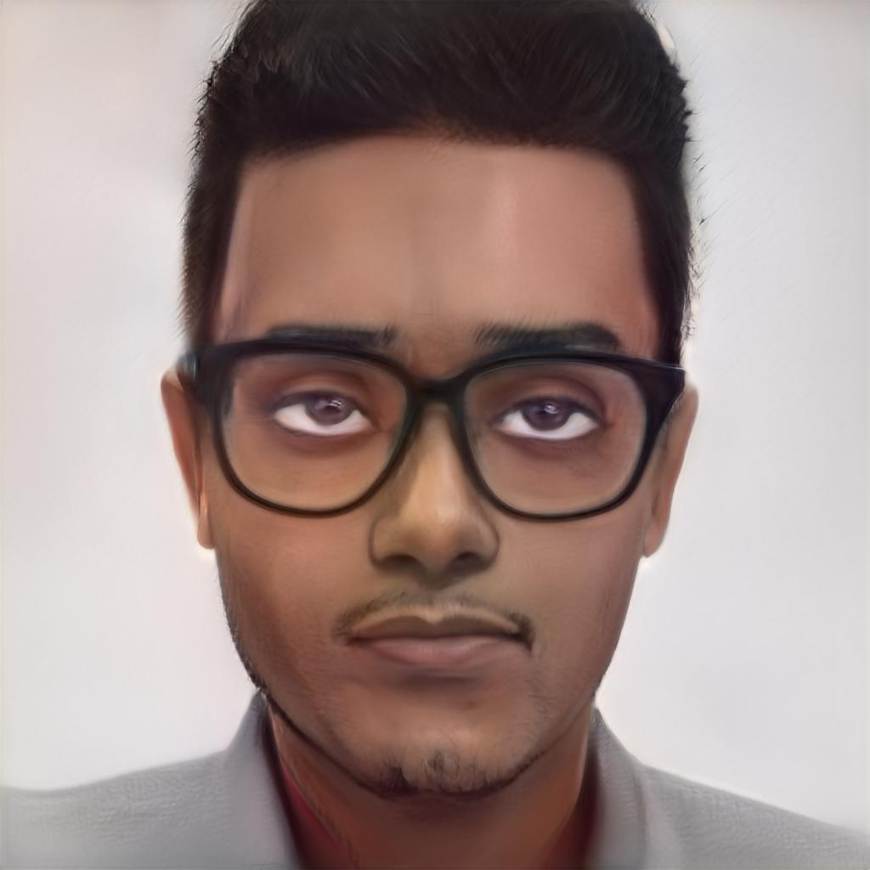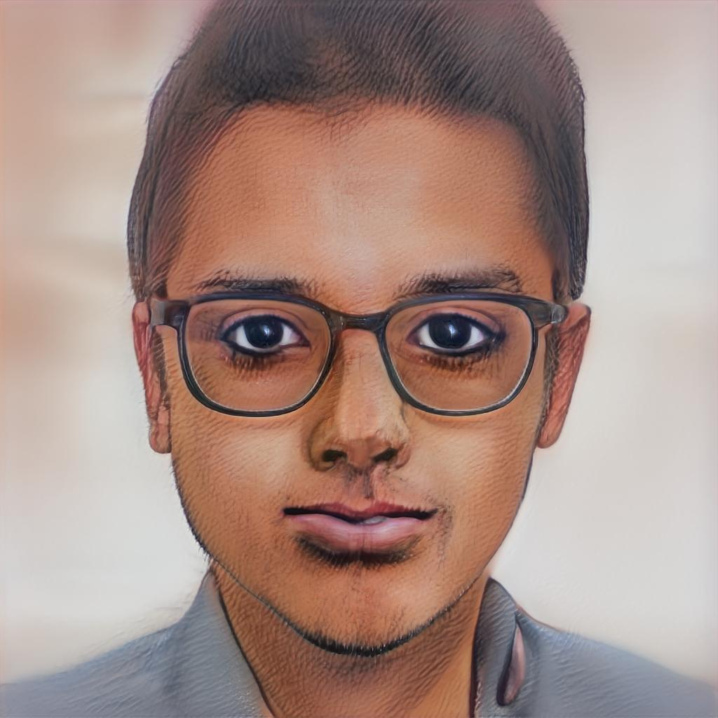

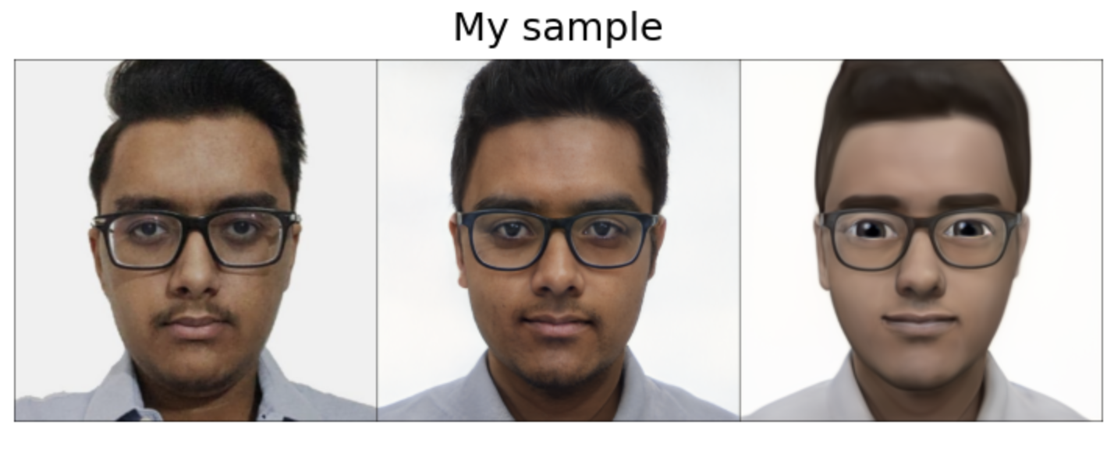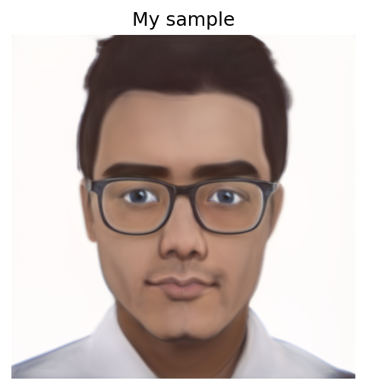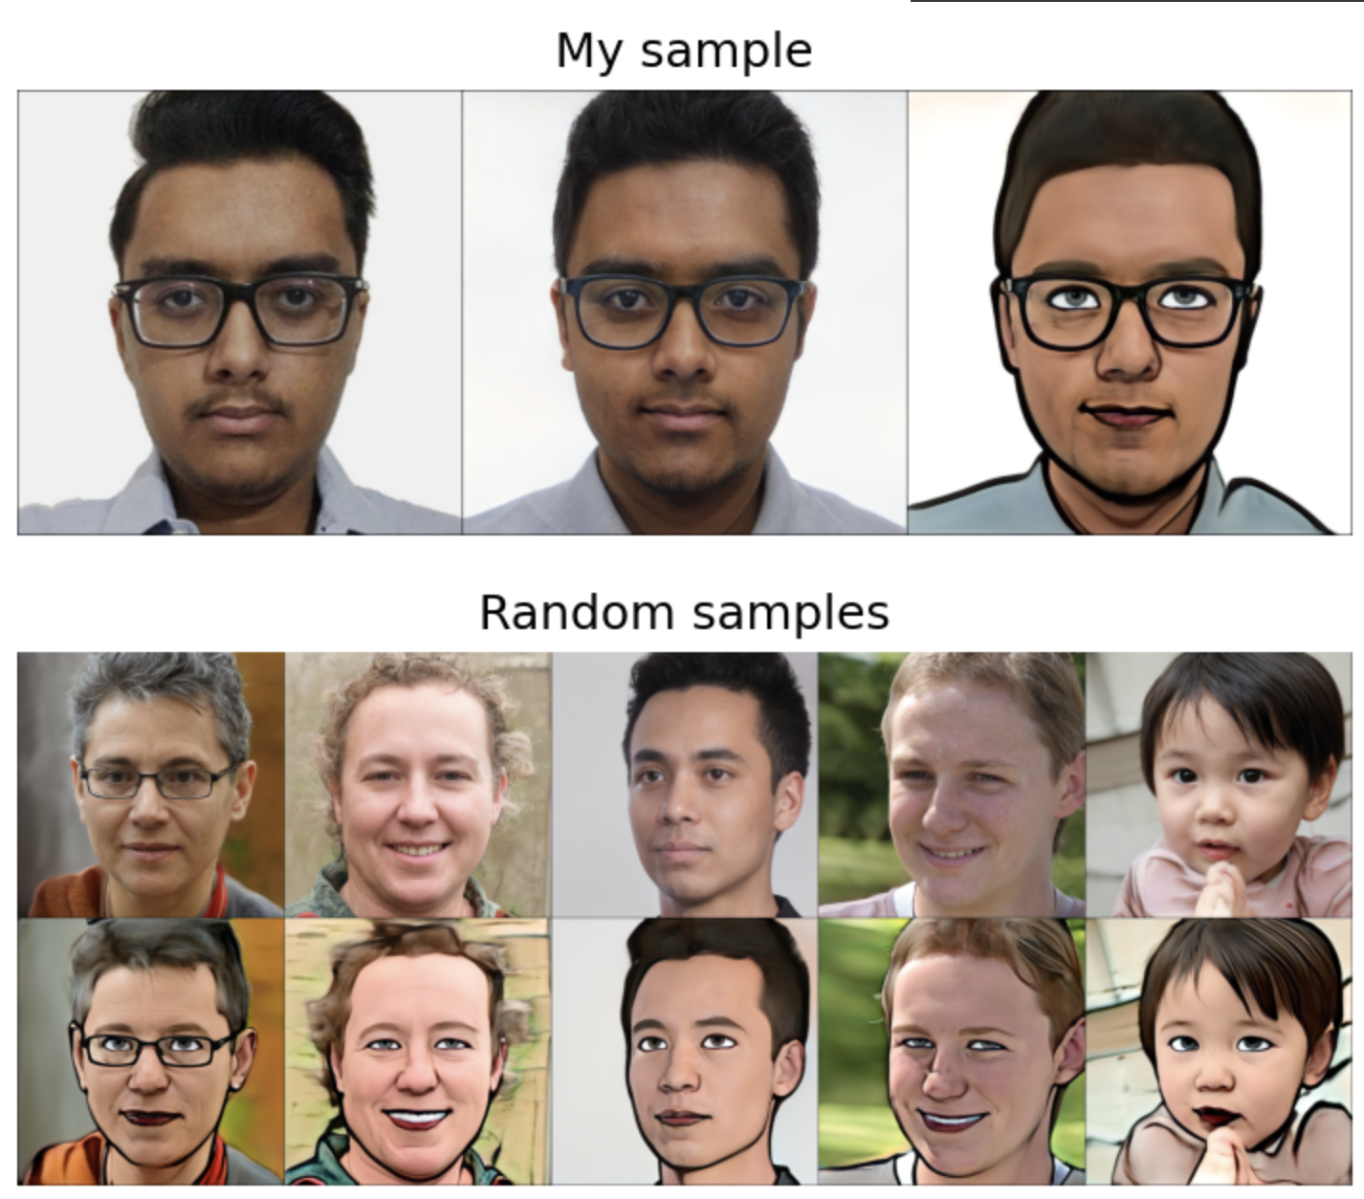

Experiments (the bottom right image is the style image used to generate the images):

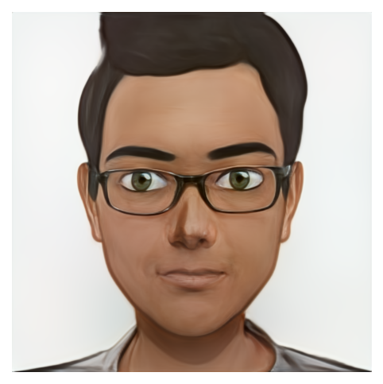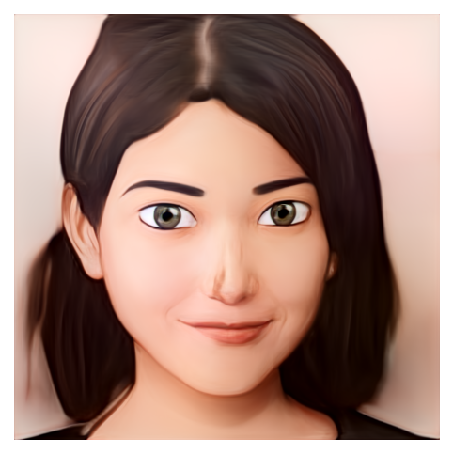

* *restyle(1)*
* *alpha(0.5)*
* *id_swap([9,11,15,16,17])*
* *num_iter(300)*
* *Adam()*

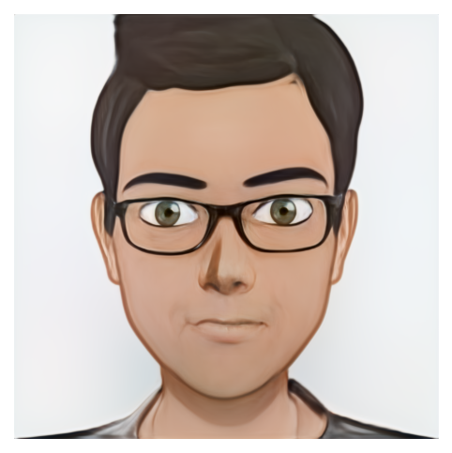

* *restyle(1)*
* *alpha(0.5)*
* *id_swap(~[9,11,15,16,17])*
* *num_iter(300)*
* *Adam()*

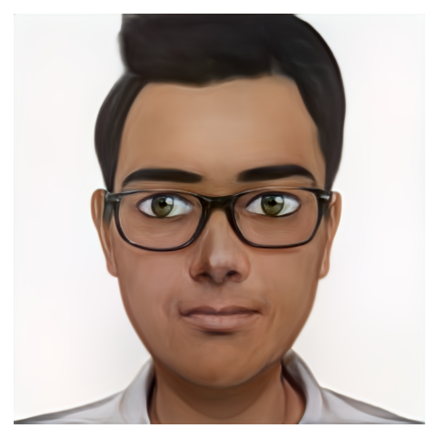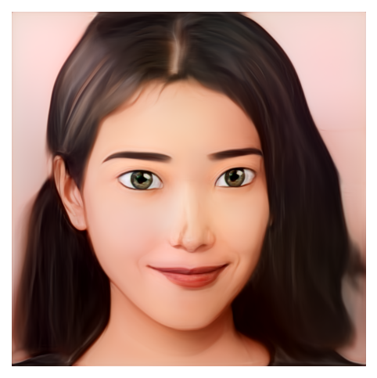

* *restyle(2)*
* *alpha(0.5)*
* *id_swap([9,11,15,16,17])*
* *num_iter(300)*
* *Adam()*

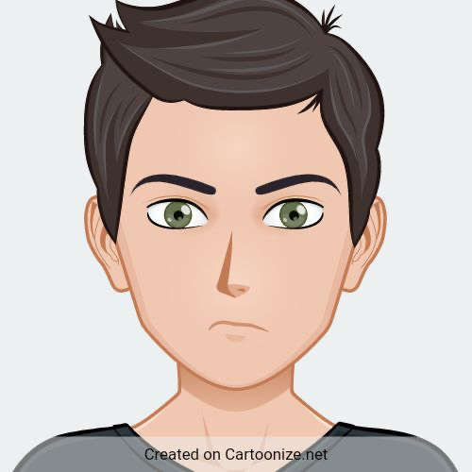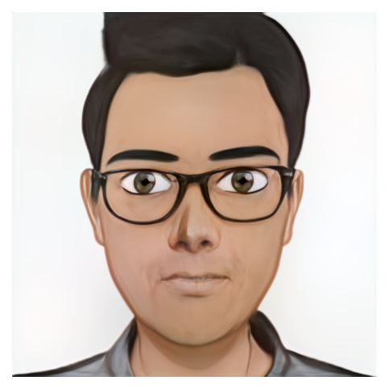

* *restyle(2)*
* *alpha(0.5)*
* *id_swap(~[9,11,15,16,17])*
* *num_iter(300)*
* *Adam()*

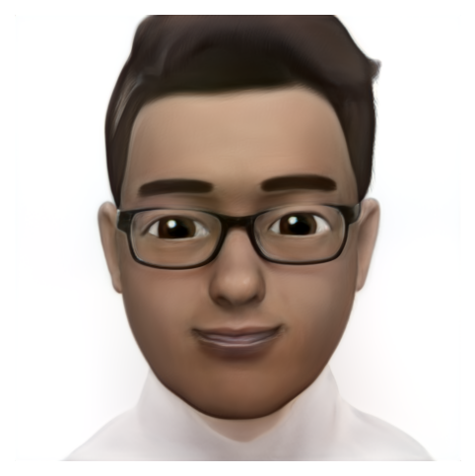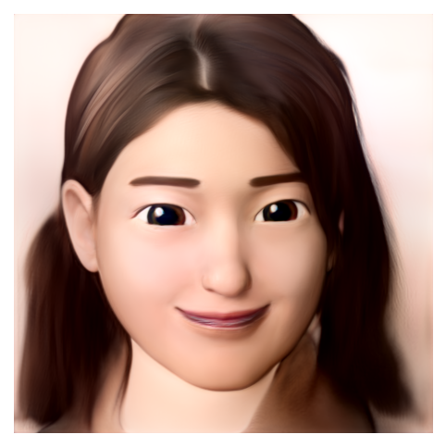

* *restyle(1)*
* *alpha(0.5)*
* *id_swap([9,11,15,16,17])*
* *num_iter(300)*
* *Adam()*

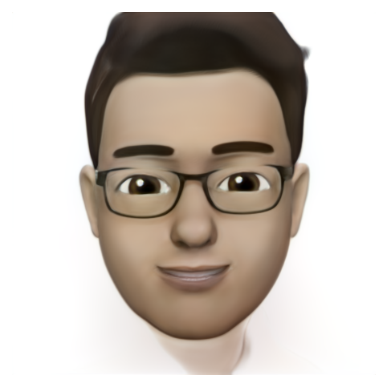

* *restyle(1)*
* *alpha(0.5)*
* *id_swap(~[9,11,15,16,17])*
* *num_iter(300)*
* *Adam()*

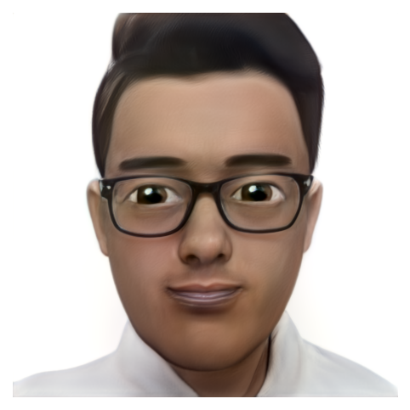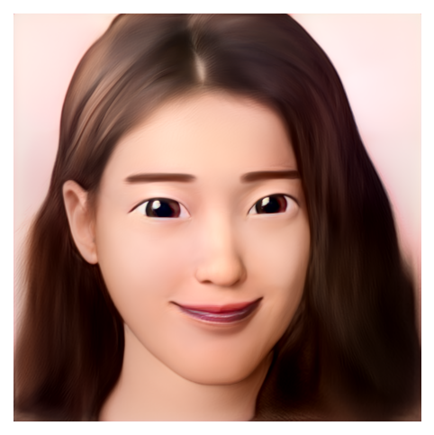

* *restyle(2)*
* *alpha(0.5)*
* *id_swap([9,11,15,16,17])*
* *num_iter(300)*
* *Adam()*

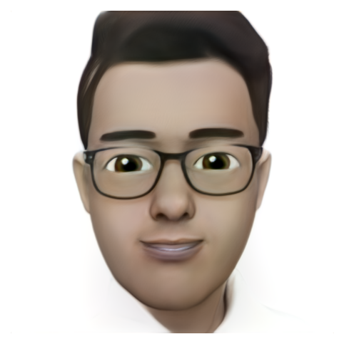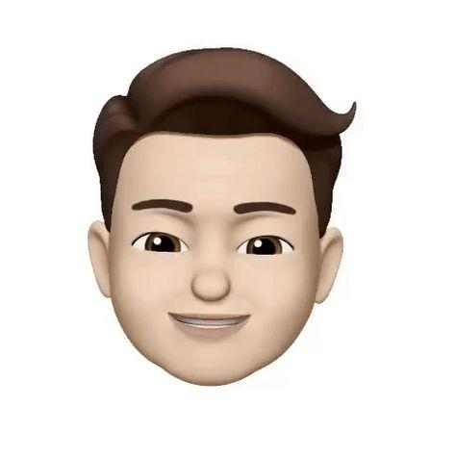

* *restyle(2)*
* *alpha(0.5)*
* *id_swap(~[9,11,15,16,17])*
* *num_iter(300)*
* *Adam()*

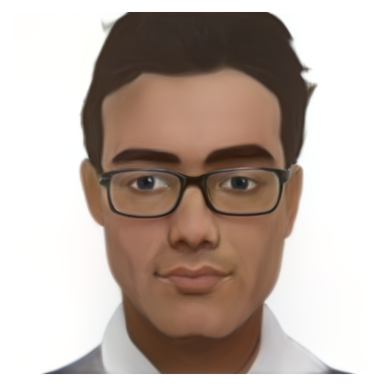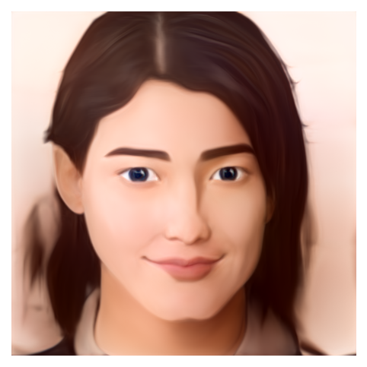

* *restyle(1)*
* *alpha(0.5)*
* *id_swap([9,11,15,16,17])*
* *num_iter(300)*
* *Adam()*

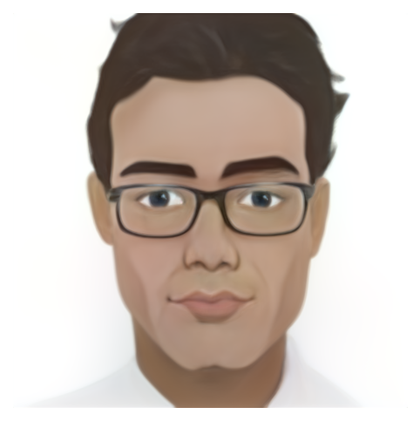

* *restyle(1)*
* *alpha(0.5)*
* *id_swap(~[9,11,15,16,17])*
* *num_iter(300)*
* Adam()

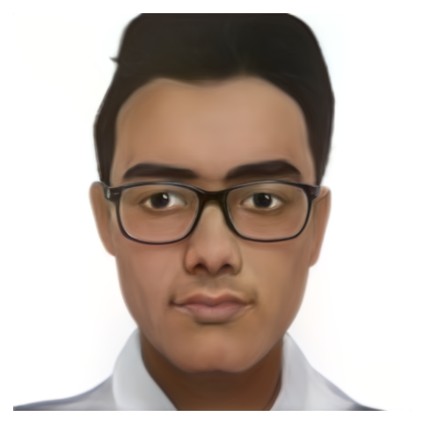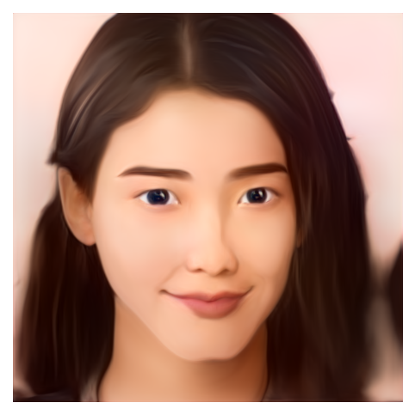

* *restyle(2)*
* *alpha(0.5)*
* *id_swap([9,11,15,16,17])*
* *num_iter(300)*
* *Adam()*

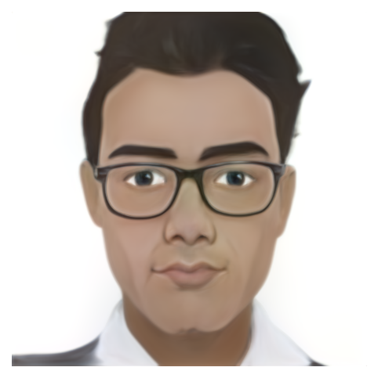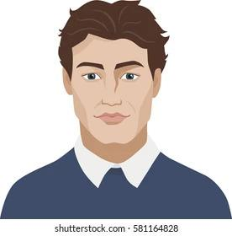

* *restyle(2)*
* *alpha(0.5)*
* *id_swap(~[9,11,15,16,17])*
* *num_iter(300)*
* Adam()

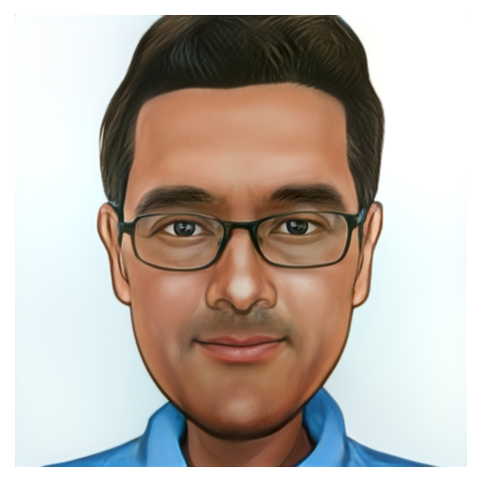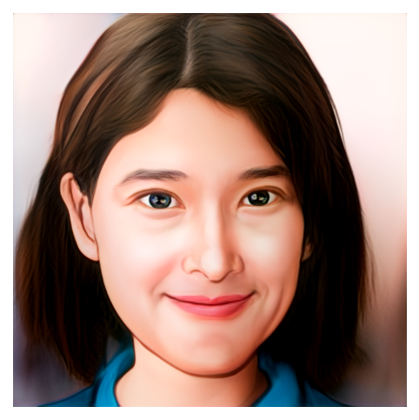

* *restyle(1)*
* *alpha(0.5)*
* *id_swap([9,11,15,16,17])*
* *num_iter(300)*
* Adam()

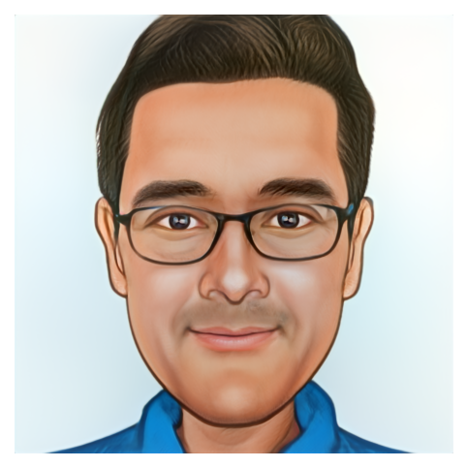

* *restyle(1)*
* *alpha(0.5)*
* *id_swap(~[9,11,15,16,17])*
* *num_iter(300)*
* Adam()

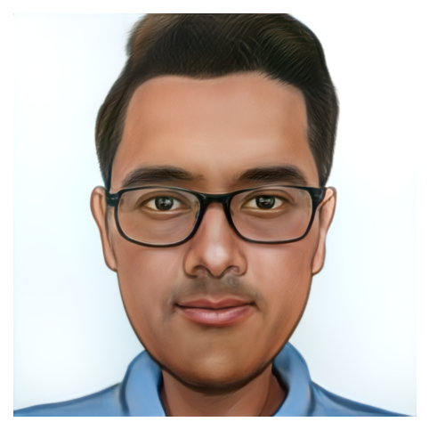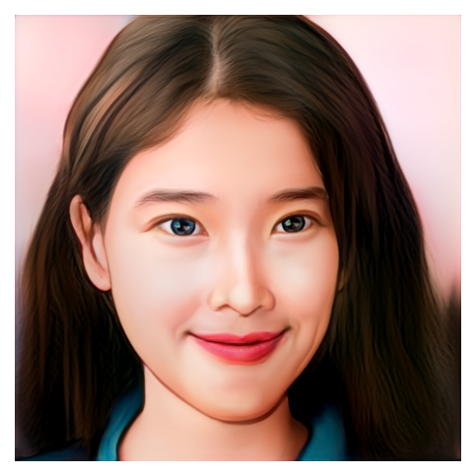

* *restyle(2)*
* *alpha(0.5)*
* *id_swap([9,11,15,16,17])*
* *num_iter(300)*
* Adam()

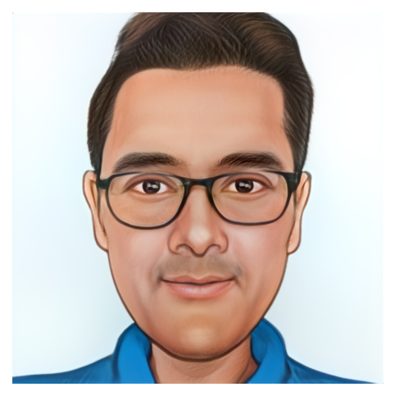

* *restyle(2)*
* *alpha(0.5)*
* *id_swap(~[9,11,15,16,17])*
* *num_iter(300)*
* Adam()

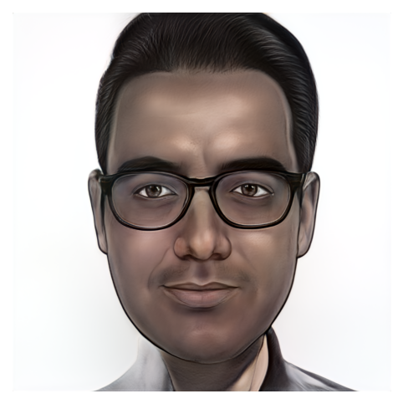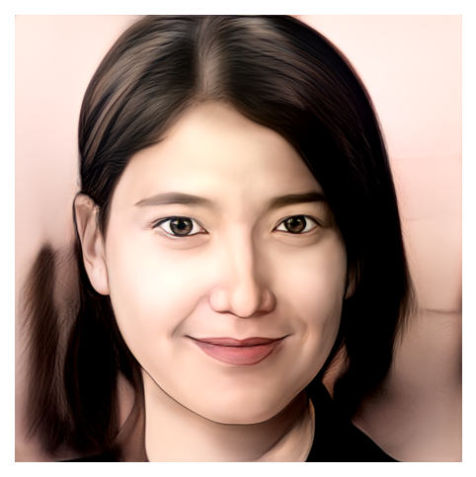

* *restyle(1)*
* *alpha(0.5)*
* *id_swap([9,11,15,16,17])*
* *num_iter(300)*
* Adam()

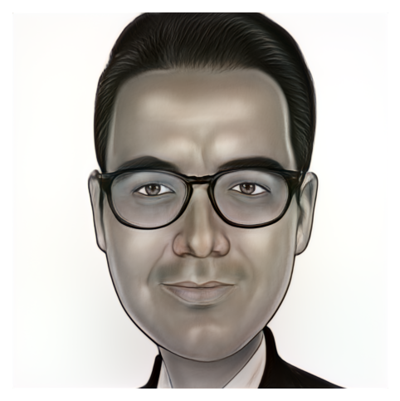

* *restyle(1)*
* *alpha(0.5)*
* *id_swap(~[9,11,15,16,17])*
* *num_iter(300)*
* Adam()

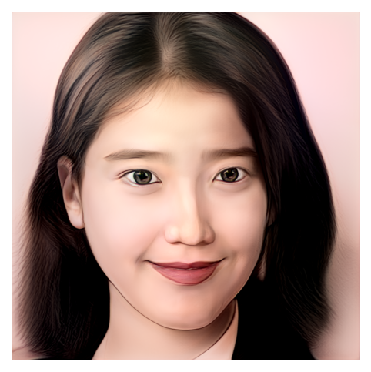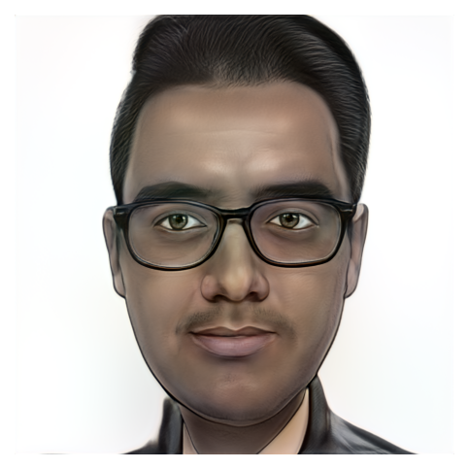

* *restyle(2)*
* *alpha(0.5)*
* *id_swap([9,11,15,16,17])*
* *num_iter(300)*
* Adam()

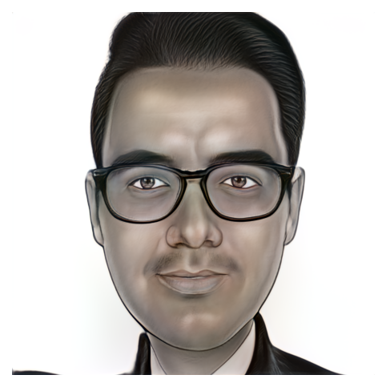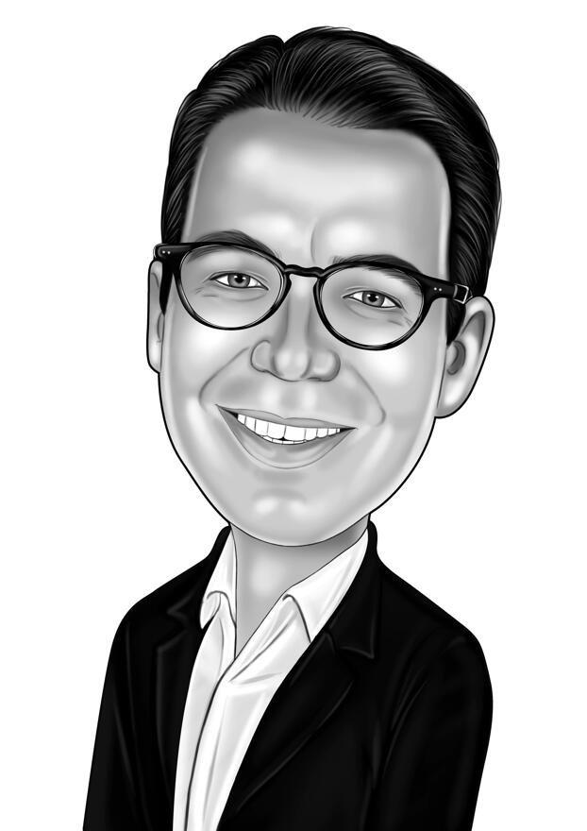

* *restyle(2)*
* *alpha(0.5)*
* *id_swap(~[9,11,15,16,17])*
* *num_iter(300)*
* Adam()

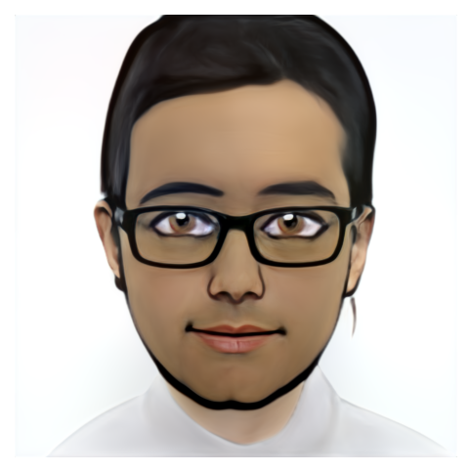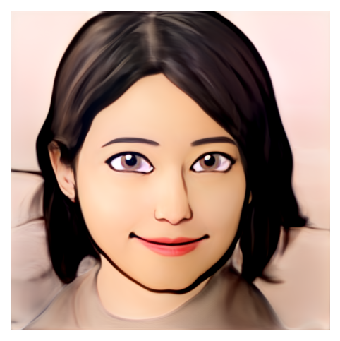

* *restyle(1)*
* *alpha(0.5)*
* *id_swap([9,11,15,16,17])*
* *num_iter(300)*
* Adam()

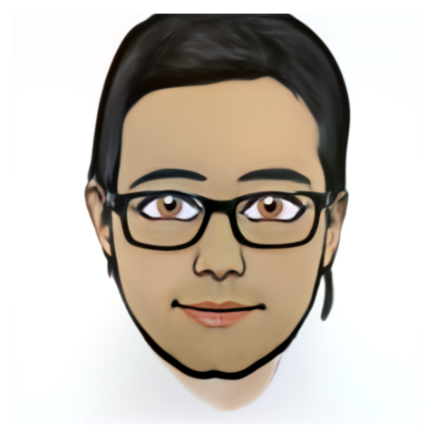

* *restyle(1)*
* *alpha(0.5)*
* *id_swap(~[9,11,15,16,17])*
* *num_iter(300)*
* Adam()

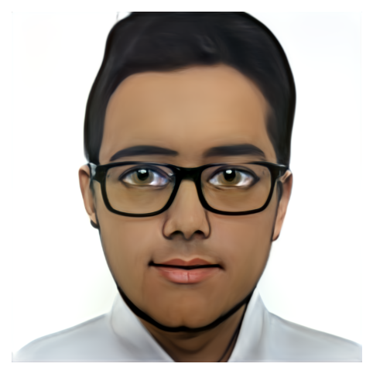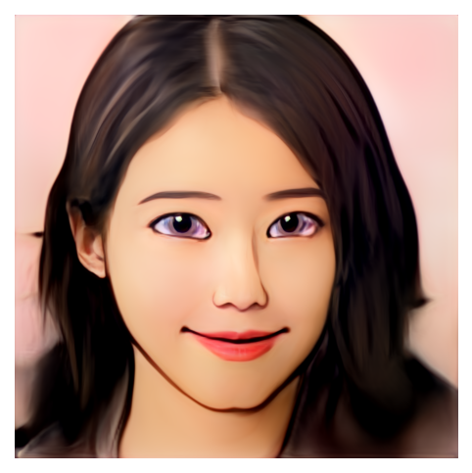

* *restyle(2)*
* *alpha(0.5)*
* *id_swap([9,11,15,16,17])*
* *num_iter(300)*
* Adam()

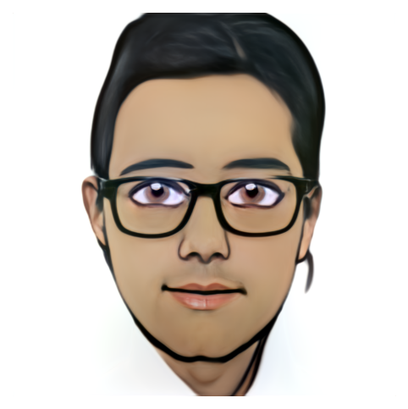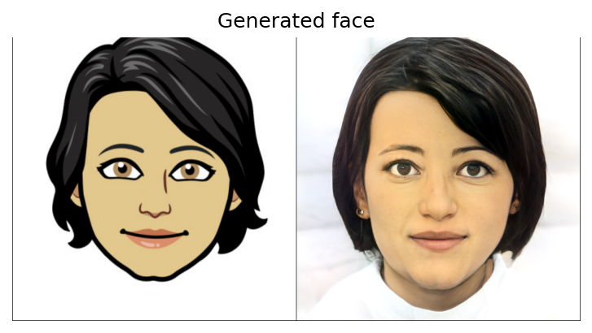

* *restyle(2)*
* *alpha(0.5)*
* *id_swap(~[9,11,15,16,17])*
* *num_iter(300)*
* Adam()

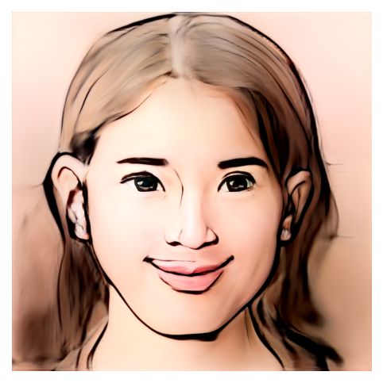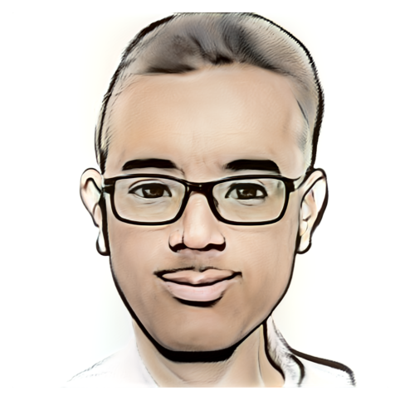

* *restyle(1)*
* *alpha(1.0)*
* *id_swap([9,11,15,16,17])*
* *num_iter(300)*

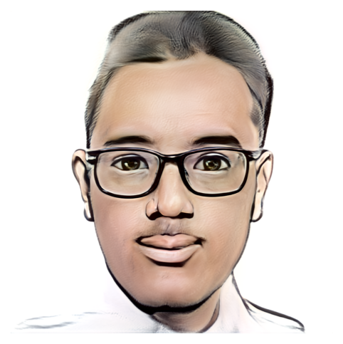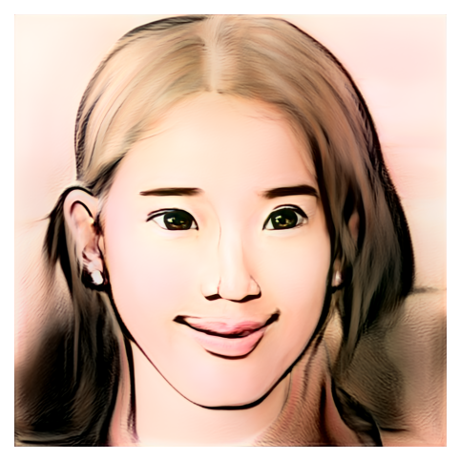

* *restyle(2)*
* *alpha(1.0)*
* *id_swap([9,11,15,16,17])*
* *num_iter(300)*

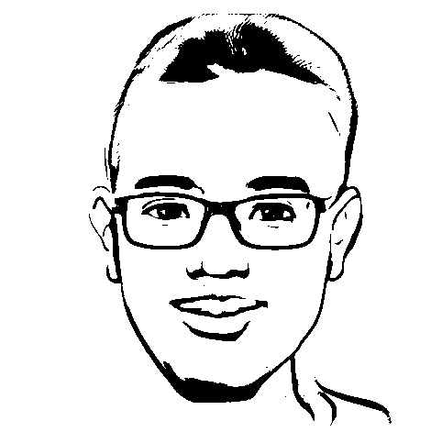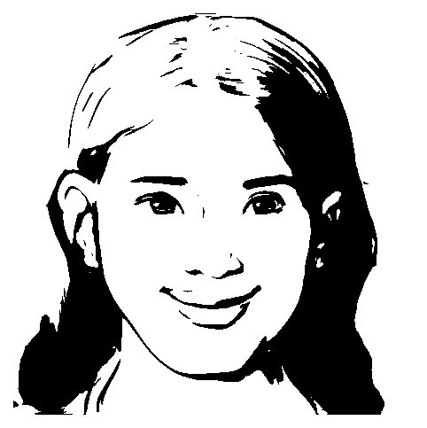

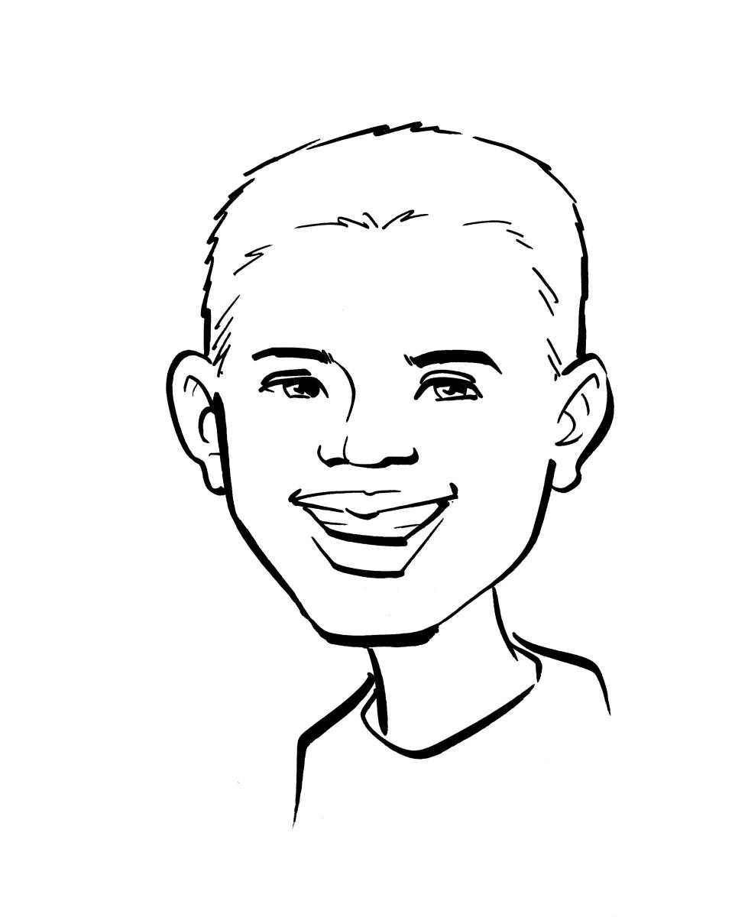

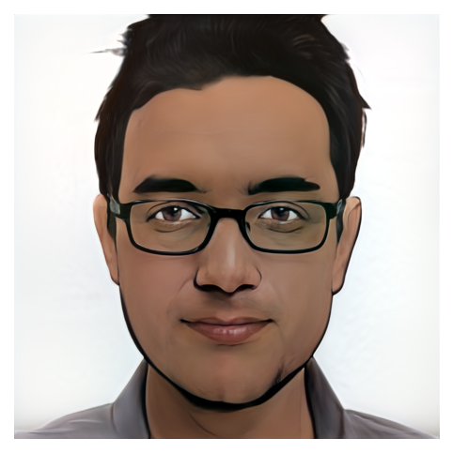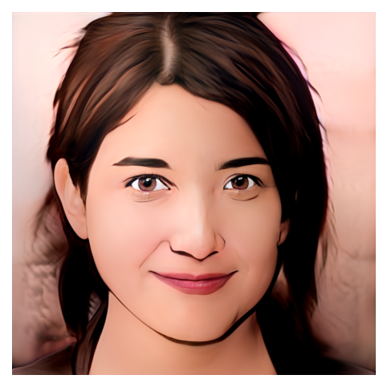

* *restyle(1)*
* *alpha(0.5)*
* *id_swap([9,11,15,16,17])*
* *num_iter(300)*

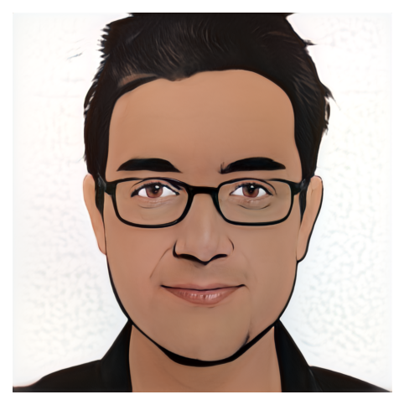

* *restyle(1)*
* *alpha(0.5)*
* *id_swap(~[9,11,15,16,17])*
* *num_iter(300)*

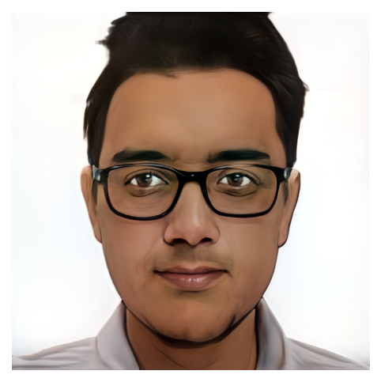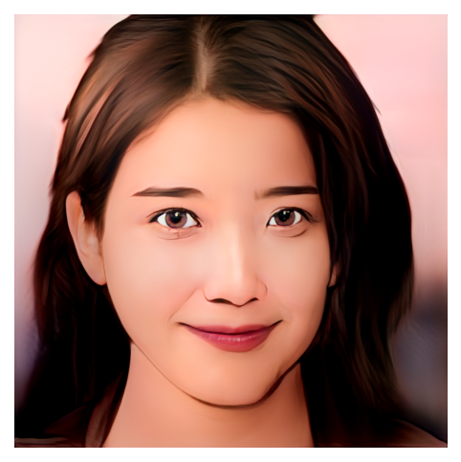

* *restyle(2)*
* *alpha(0.5)*
* *id_swap([9,11,15,16,17])*
* *num_iter(300)*

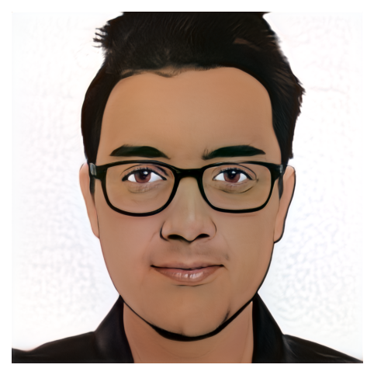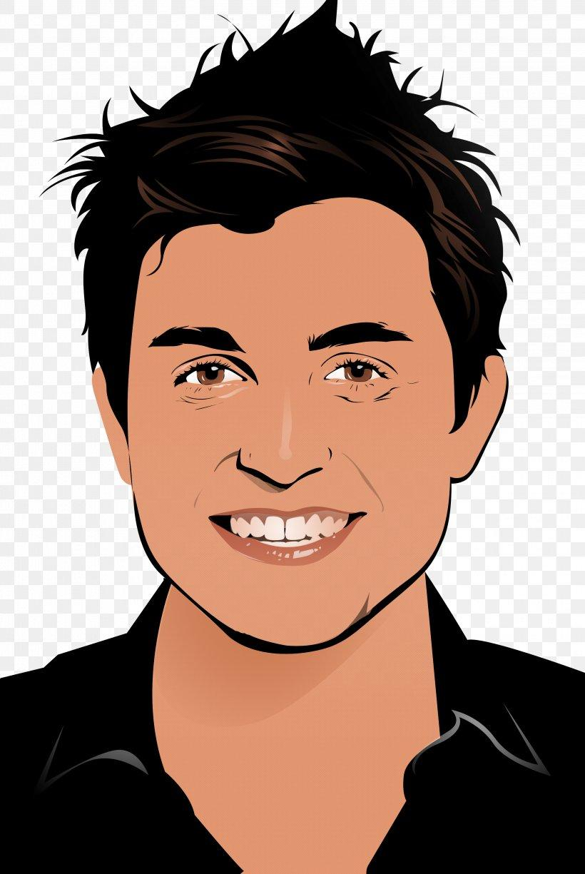

* *restyle(2)*
* *alpha(0.5)*
* *id_swap(~[9,11,15,16,17])*
* *num_iter(300)*

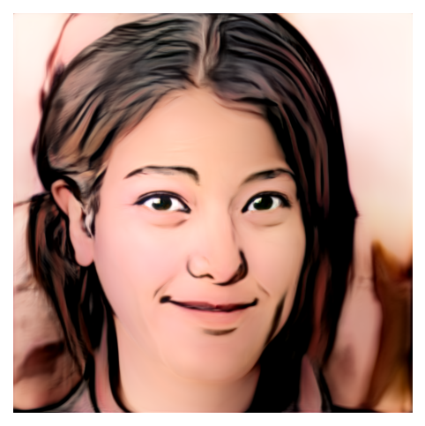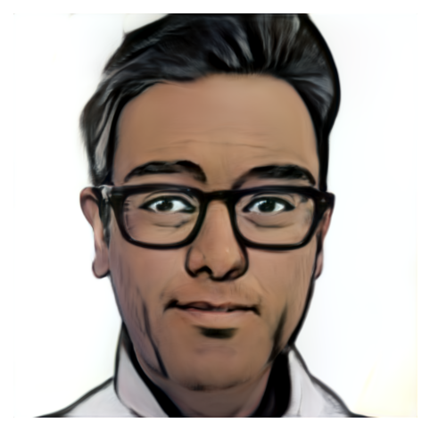

* *restyle(1)*
* *alpha(0.5)*
* *id_swap([9,11,15,16,17])*
* *num_iter(300)*

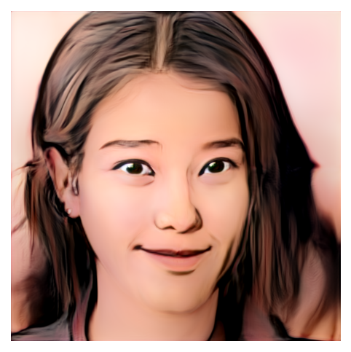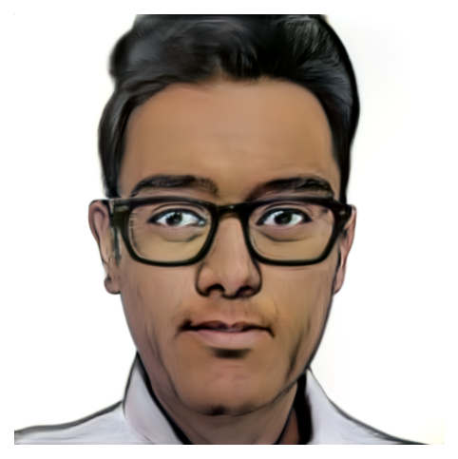

* *restyle(2)*
* *alpha(0.5)*
* *id_swap([9,11,15,16,17])*
* *num_iter(300)* 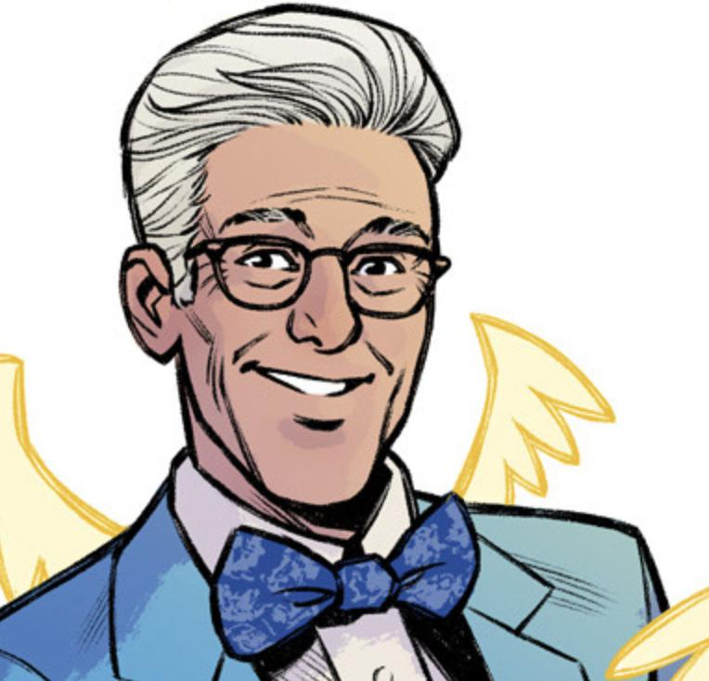

**Week 4**

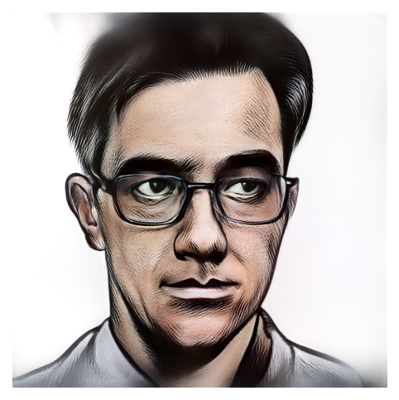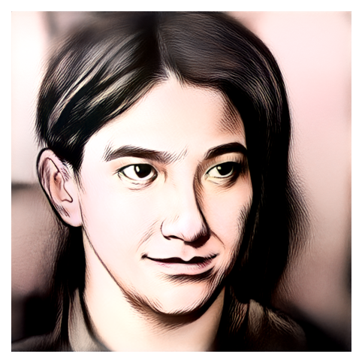

* *restyle(1)*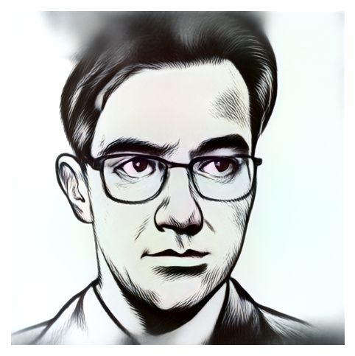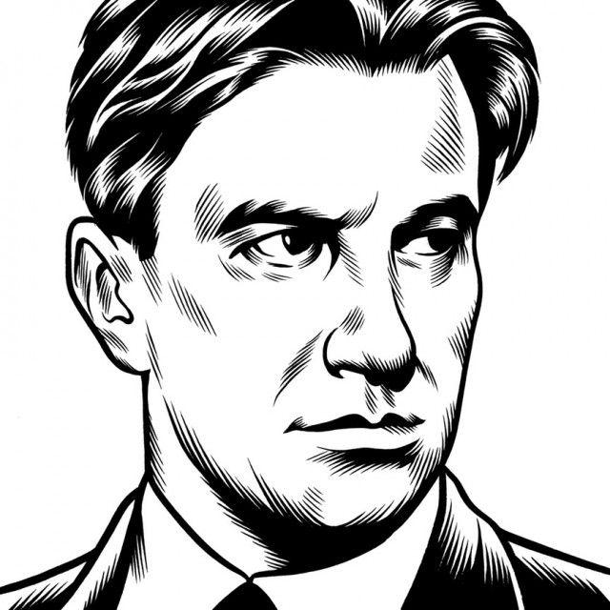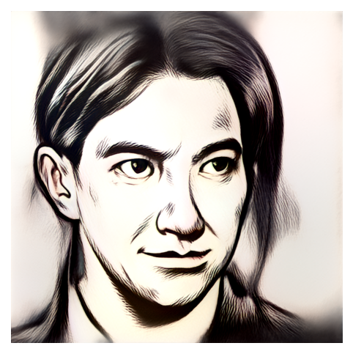
* *alpha(1.0)*
* *id_swap([9,11,15,16,17])*
* *num_iter(300)*
* *restyle(1)*
* *alpha(1.0)*
* *id_swap(~[9,11,15,16,17])*
* *num_iter(300)*

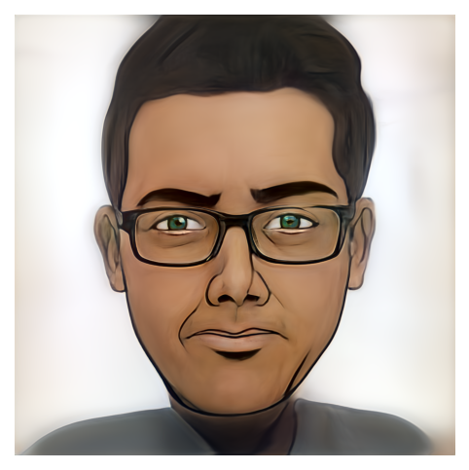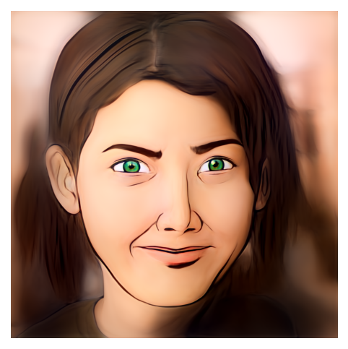

* *restyle(1)*
* *alpha(0.5)*
* *id_swap([9,11,15,16,17])*
* *num_iter(300)*

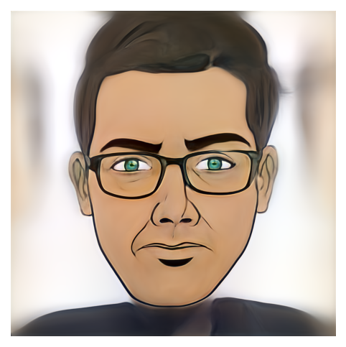

* *restyle(1)*
* *alpha(0.5)*
* *id_swap(~[9,11,15,16,17])*
* *num_iter(300)*

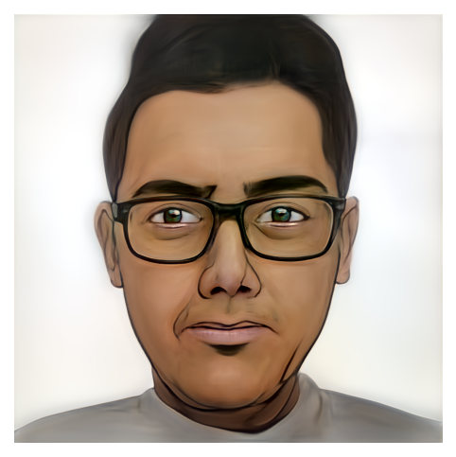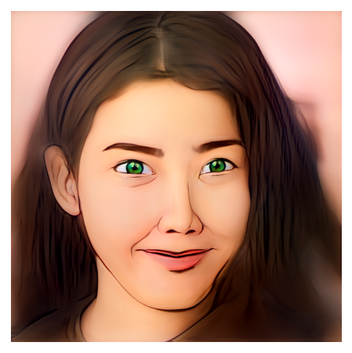

* *restyle(2)*
* *alpha(0.5)*
* *id_swap([9,11,15,16,17])*
* *num_iter(300)*

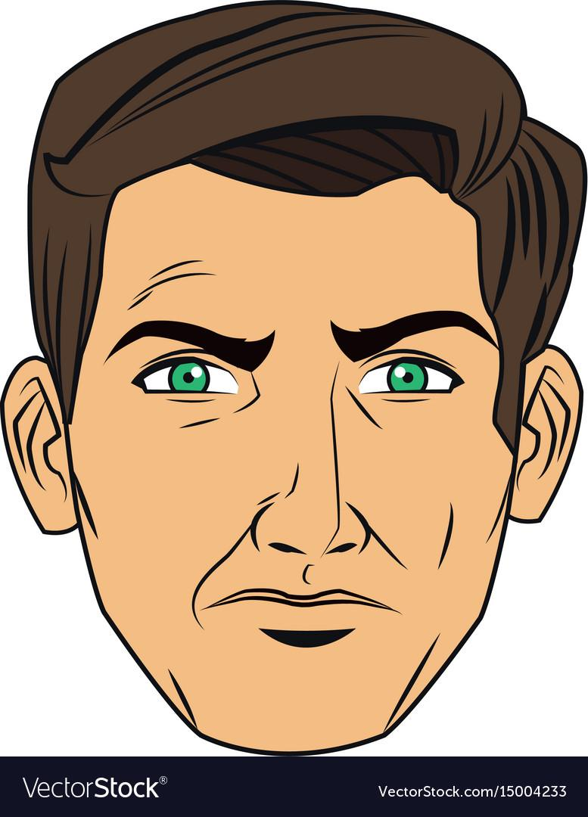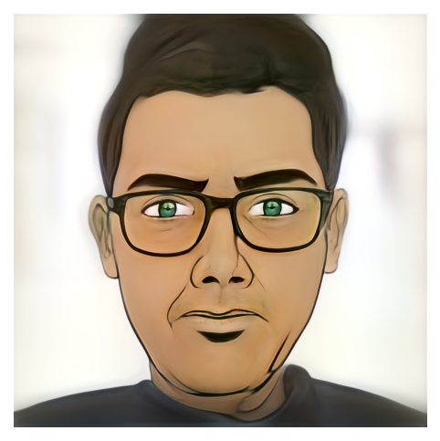

* *restyle(1)*
* *alpha(0.5)*
* *id_swap(~[9,11,15,16,17])*
* *num_iter(300)*

Notes and tasks to be done:

* Results in the 2nd page of experiments preferable for our use case.
* Prepare a presentation on the tasks and research done so far in a clear and concise manner to present to the manager. Use PhonePe template (<https://docs.google.com/presentation/d/159Ixz38K0FGCOEcoiPOd56yZ4rA32l28-R6_ooX-LwQ/edit#slide=id.g1322fae506b_0_100>): ✅
* Read CariGAN research paper and see whether we can incorporate some learning from it into our custom JoJoGAN for caricature style: ✅

CariGAN (no implementation available):

* Unpaired cross-domain image-to-image translation.
* CariGAN ← CariGeoGAN (uses [CycleGAN](https://github.com/junyanz/CycleGAN)) + CariStyGAN (uses CycleGAN + [MUNIT](https://github.com/NVlabs/MUNIT))
* CariGeoGAN models the geometry-to-geometry transformation from face photos to caricatures. CariStyGAN transfers the style appearance from caricatures to face photos without any geometry deformation. Both the models are independent and combined using image warping.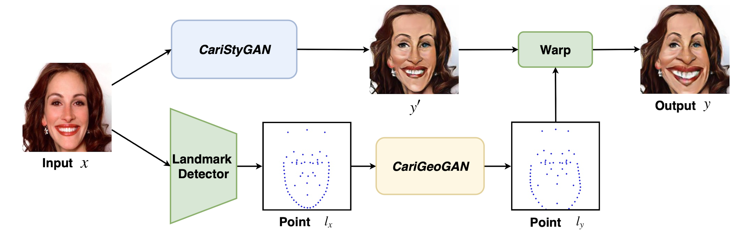
* Can control the shape exaggeration degree and change the color/texture style by tuning the parameters or giving an example caricature:

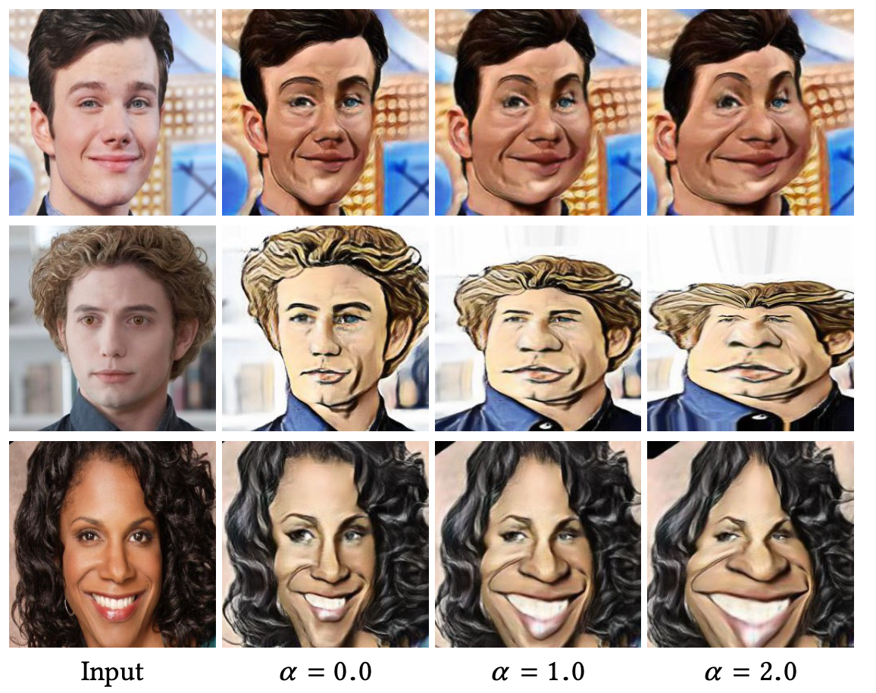

* What we can do is use CariGeoGAN and JoJoGAN (instead of CariStyGAN) and combine them. Also, the styles in the training caricature dataset have only been learned by the CariStyGAN meaning we can only give custom style that is present in the dataset. Here also, the styles which are uncommon in the dataset do no translate well.
* CariGeoGAN (<https://github.com/imaccormick275/cariGAN>):
  + Training data: they have used manually labeled 63 landmarks for each photo (10,000 randomly sampled images from CelebA) and caricature image (8,541 hand-drawn portrait caricatures from the Internet). We cannot do manual labeling.

Can use alternative dataset – WebCaricature (<https://cs.nju.edu.cn/rl/WebCaricature.htm>) which contains 6,042 caricatures and 5,974 photographs from 252 persons with 17 labeled facial landmarks each. Need to fill the dataset release agreement.

* + Inspired by the network architecture of CycleGAN. It contains two generators and two discriminators. CariGeoGAN is different from CycleGAN since it takes PCA vector instead of image as input and output.
  + The architecture is as shown below:
  + Three losses are used – adversarial, cycle-consistency and characteristic loss. The first two losses combined are still weak to guarantee that the predicted deformation can capture the distinct facial features and then exaggerate them. So, a new characteristic loss is added which penalizes the cosine differences between input landmark and the predicted one. The complete loss is: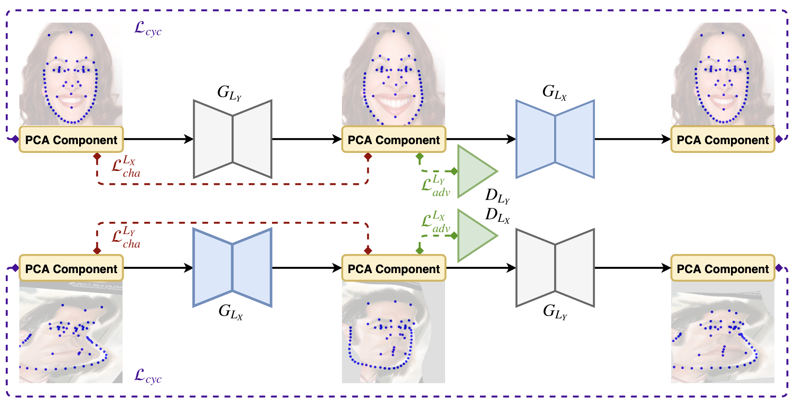



* Some examples of style transfer using user provided style images in CariGAN: 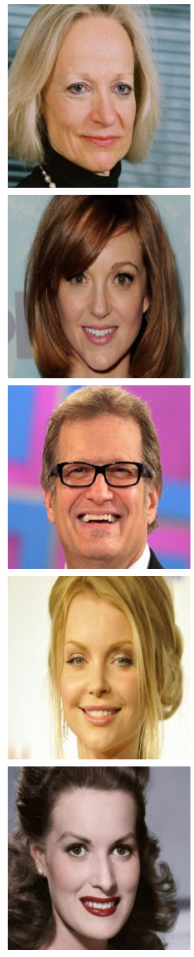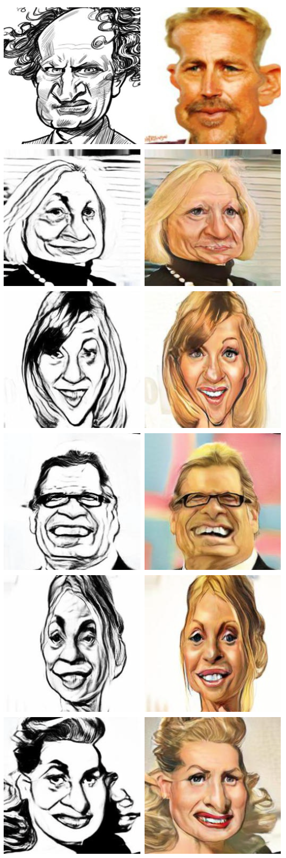

**Week 5**

Need to warp the stylized faces generated by JoJoGAN to create a caricature like effect. Some options are as follows:

* Use CariGeoGAN. Need WebCaricature dataset access.
* Learn the warping using facial landmarks on a per caricature basis. Only one photo needed per caricature style.
* Try the WarpGAN’s Geometric Deformation module. An issue on github has been raised on github regarding this (<https://github.com/seasonSH/WarpGAN/issues/11>)

Important observation:

* For integration of warping with style (from JoJoGAN), we can simply first pass the image through the warping module and then apply JoJoGAN with 4-5 iterations of ReStyle.
* This is to ensure that the overall shape is affected by the given image and not the style image. Example with a manually warped image:

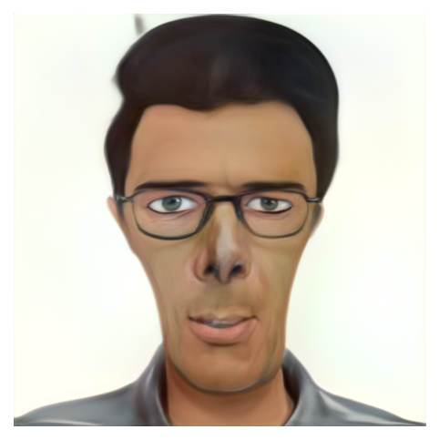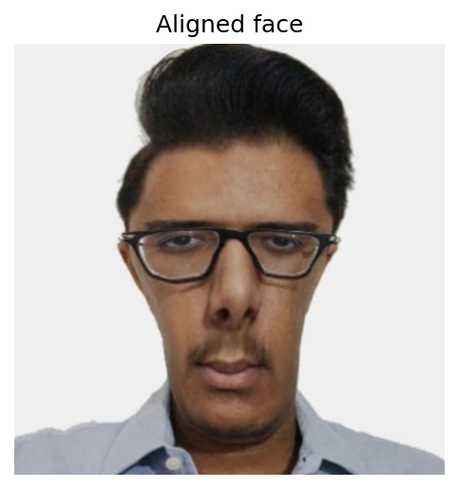

Prerequisites for AGIS-Net:

* Pix2Pix: <https://sh-tsang.medium.com/review-pix2pix-image-to-image-translation-with-conditional-adversarial-networks-gan-ac85d8ecead2>
* U-Net: <https://towardsdatascience.com/unet-line-by-line-explanation-9b191c76baf5>
* PatchGAN: <https://sahiltinky94.medium.com/understanding-patchgan-9f3c8380c207>

AGIS-Net (<https://github.com/hologerry/AGIS-Net>):

* Can transfer both shape and texture style in one stage using few-shot learning.
* One stage model: the generator directly outputs stylized glyph images with user-specified contents and styles.
* Architecture overview: two encoders to extract content and style features separately, and two parallel decoders to recover glyph shape style and texture style.
* Pre-train on the entire dataset. Fine-tune on any style we want. Dataset should have three images per character – content image (in *Code New Roman* font), B&W style image (for shape) and textured style image (for texture):



* The detailed architecture is as follows: 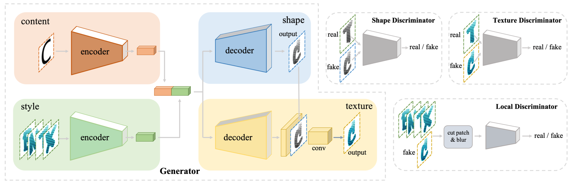
* Generator: The encoder-decoder architecture is integrated via skip connections as in Pix2Pix’s U-Net. The features at different scales are all important. For example, higher-level features contain more abstract style information while lower-level features contain more specific style information. So skip connections help in learning them using this extra information.

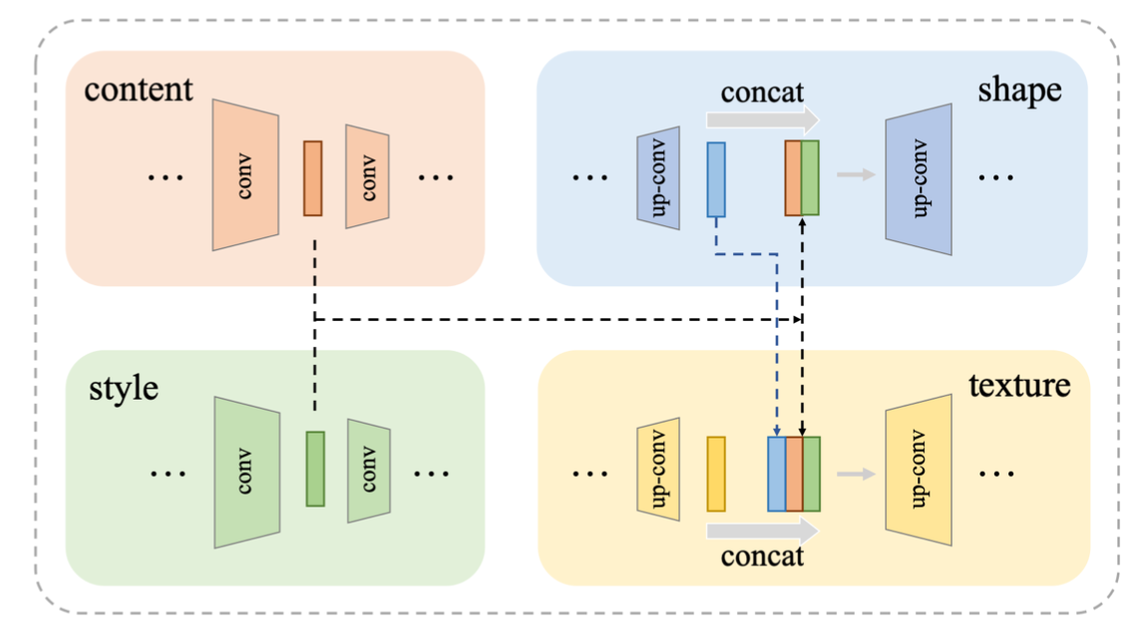

* Discriminator: There are 3 discriminators. The first two, Dsha and Dtex, are like PatchGAN. The third one, Dlocal, is used for refining local textures.
* 4 losses used: *Ladv, L1, LCX, Lloca*l. The first two losses – adversarial and L1 need no explaining.
  + *LCX* (contextual loss): it is an effective way to measure the similarity between two images, requiring no spatial alignment. It leads the model to pay more attention to style features at a high level, not just differences in pixel values:

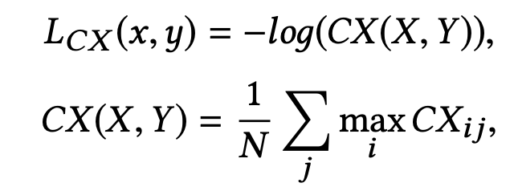

* + *Llocal* (local texture refinement loss): the positive and negative samples are highly unbalanced in the few-shot reference set. This loss adresses this problem by using the following method:

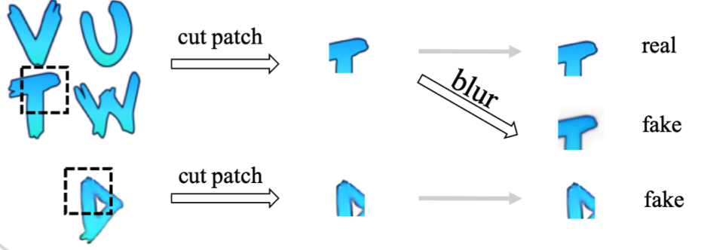

* Dataset: English glyph image dataset which contains 32,046 synthetic artistic fonts, each with 26 glyphs for pre-training:

The test set for fine-tuning contains 35 professional-designed English fonts with special text effects. 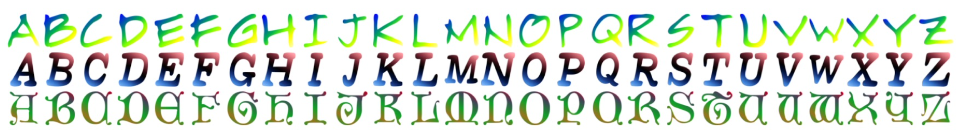

* The English glyph image dataset only contains 26 capital letters. So, doesn’t generalize for small letters:

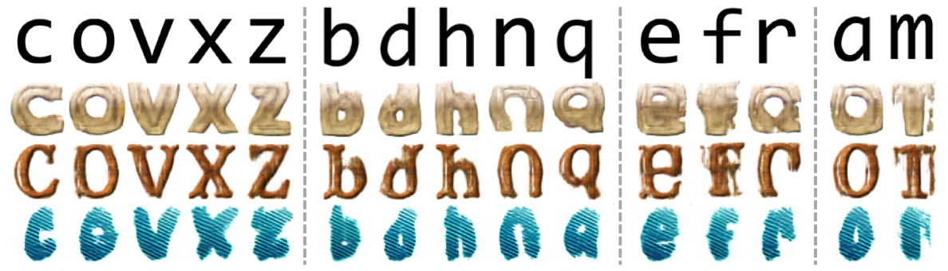

* Also, there are some failure cases for capital letters as well:

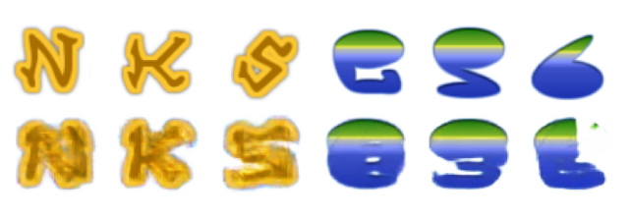

* Since JoJoGAN is a general model, can we extend it to the font style transfer as well? If not, then why?
* Continue training AGIS-Net
* Discovered new quirk: GAN inversion is highly sensitive to alignment. So different manual alignments give varying results.
* Take a creative from the net, remove the face, apply JoJoGAN on a user’s face with the creative’s style and then try to merge the face onto the creative. Show the results.
  + Example creative:



* + Manually cropped face: Tried with various manual alignments.

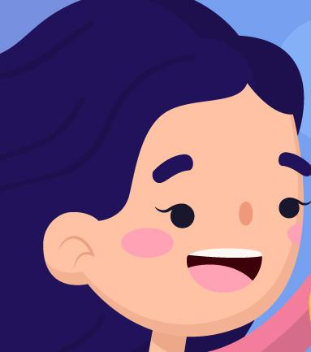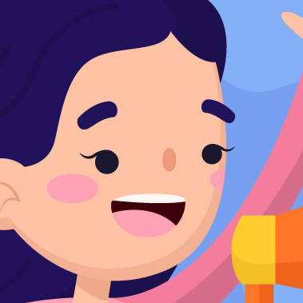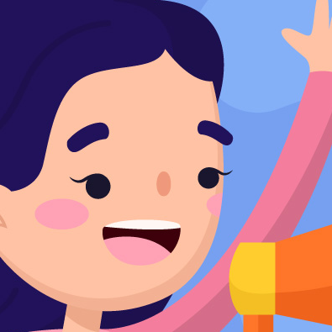

* + Some acceptable results with different parameters:

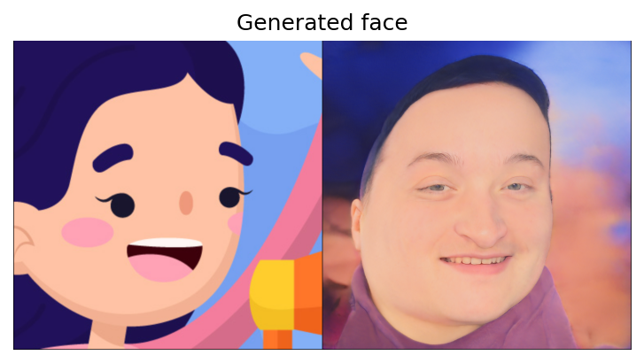

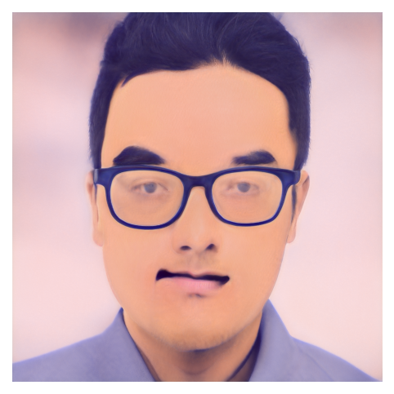

g_optim = Adam(lr=2e-4, betas=(0, 0.99))

iterations = 300

alpha = 1

projection = e4e

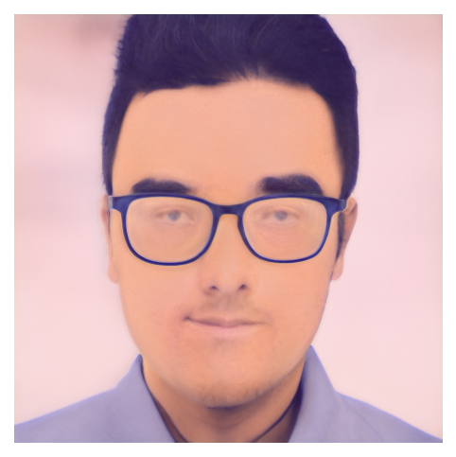

g_optim = Adam(lr=2e-4, betas=(0.9, 0.99))

iterations = 300

alpha = 1

projection = e4e

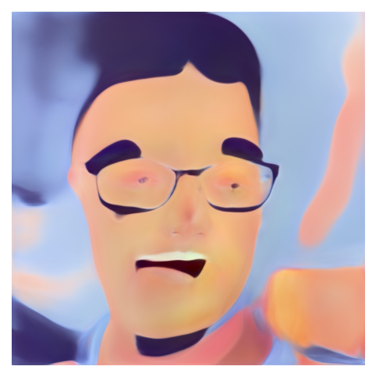

g_optim = Adam(lr=2e-3, betas=(0, 0.99))

iterations = 300

alpha = 1

projection = e4e

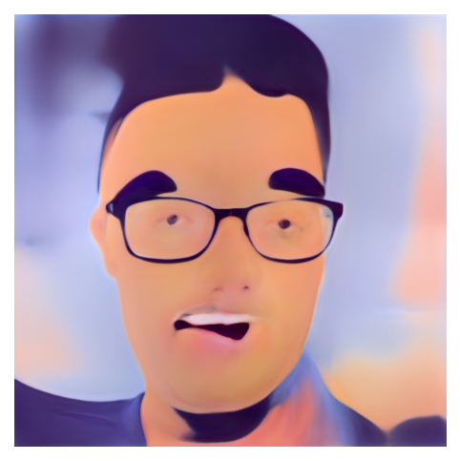

g_optim = Adam(lr=1e-3, betas=(0, 0.99))

iterations = 300

alpha = 1

projection = e4e

Result of manual blending:



What we can do to make this automatic (pipeline):

* Apply JoJoGAN on user’s face with the creative’s style.
* Remove background from this image to only get the face image.
* Insert and resize this face into the creative at fixed coordinates.
* Blend both the images to match the color of face, hair, etc.
* What to do about creative’s background if we remove the girl’s hair? Not for now.
* Should we go the GAN way? Problem with face detection in non-human looking faces. Use image processing methods.

**Week 6**

* Decided on using the previously mentioned pipeline for adding user image to creative.
* The project’s complete pipeline is as follows:
  + inputs: user image, stylized font and a creative with text and image in it
  + output: the creative with the text replaced in the stylized font provided and the image’s face replaced replaced with user’s stylized face.
* Start creating code for the font generation using stylized font.
* For facial blending, we can use *seamless cloning* or related methods as used in <https://github.com/Tismoney/FaceSwapping>
* Look into isolating face from the JoJoGAN’s output:
  + comes under the use case of *face parsing* or *face segmentation*.
  + some models:
    - <https://github.com/zllrunning/face-parsing.PyTorch>
    - <https://github.com/shaoanlu/face_toolbox_keras>: ready to use out of the box, Uses the first model in internally.
    - <https://github.com/hhj1897/face_parsing>: only for videos
  + Going with the second model (BiSeNet model) Takes 2.9s per image. Should we remove hair or not? Created code to extract face from stylized face image.

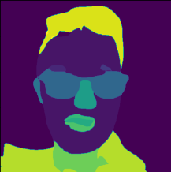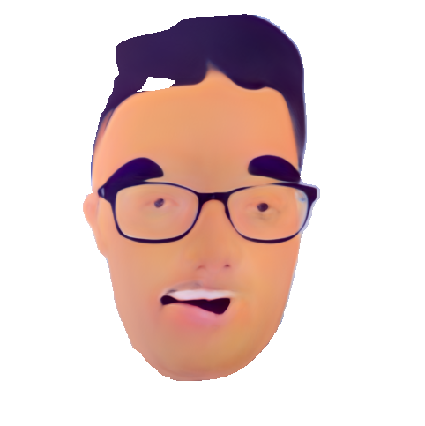

* Next step is inserting face into the creative image. Created code for inserting image at fixed coordinates in the creative. Takes 0.15s. So total time for face extraction and insertion is 3.05s per image. Need to test for generalization with some more images.
* Next step is blending.
  + Normal seamless cloning:



* + Alpha blending: very simple. Not good for our use case.
  + Seamless cloning without skin i.e. with only eyes, nose and mouth: not good results
  + Try removing background from creative and insert the face as it is: not good for creatives where the face contains lot of information in the surroundings.
  + Match color of the face using existing models / tools.
  + Note regarding current blending method: Need to manually provide values for positioning, scaling factor and rotation angle. But its only a one time thing per creative.
  + Some more examples to test for generalization:

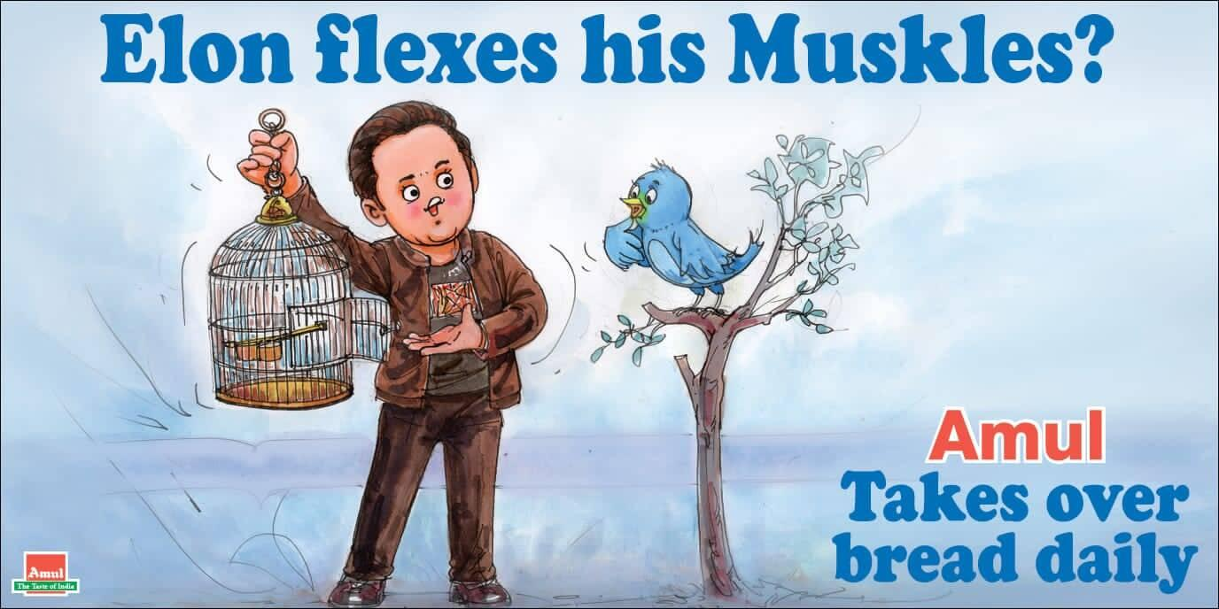

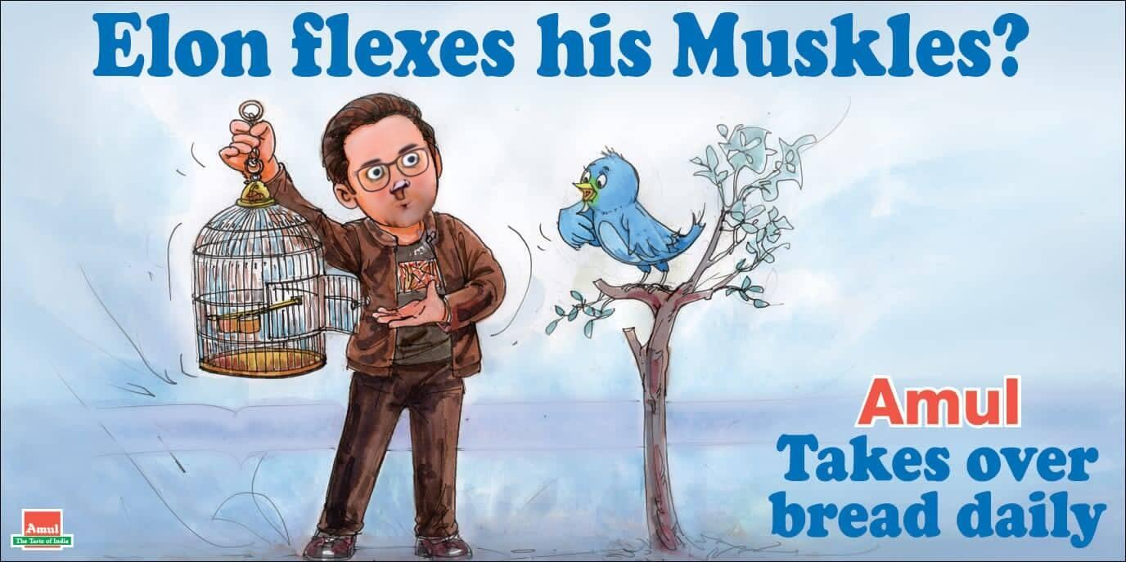

* + Takes 3.5s per image which is just 0.5s more than simply cropping and inserting. Breakdown of time taken per component:
    - Insignificant: Rotation: 0.002s, Scaling: 0.001s, Cloning: 0.022s
    - Significant: Mask: 2.768s, Cropping: 0.663s
    - Total: 3.4s ~ 3.5s
  + Integrated dynamic scaling as well as defined order of operations which give the best results. Cropping after rotating is important for fixed positioning. Holes are also filled after masking.
  + Seamless cloning (*NORMAL_CLONE*) internally uses Poisson editing.
  + To help seamless cloning, in the JoJoGAN step, we can experiment with hyperparameters such that the stylized image’s texture is as close to the reference as possible
  + Same creative, different face:

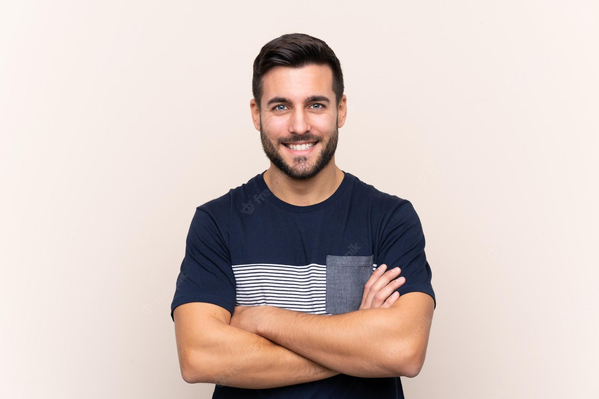

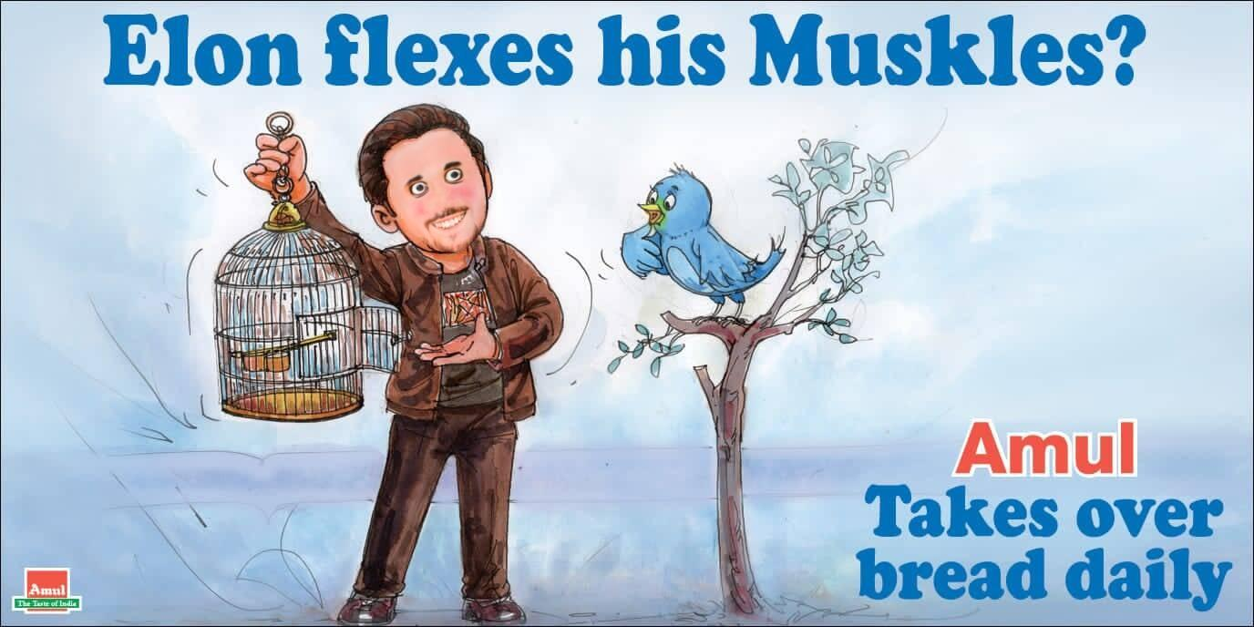

**Week 7**

Font Style Transfer Pipeline (need GPU):

* Load generator with saved checkpoints: Needed to dig into code to see how exactly the generator is defined and what parameters are used.
* Generate stylized font images (given input character and textures):

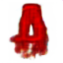

* Crop font images to edges to allow for padding: Crop the font image from the left and right to allow for horizontal padding. For vertical padding, do the same from top and bottom instead.
* Concatenate characters to generate text (given input text, padding, direction of text). We can also do this for any angular direction (just need a general function):
  + Padding = 10, Direction = Horizontal

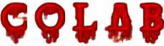

* + Padding = 20, Direction = Horizontal

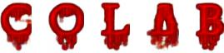

* + Padding = 10, Direction = Vertical



* Insert the stylized text into the creative (given coordinates of text, scaling factor):

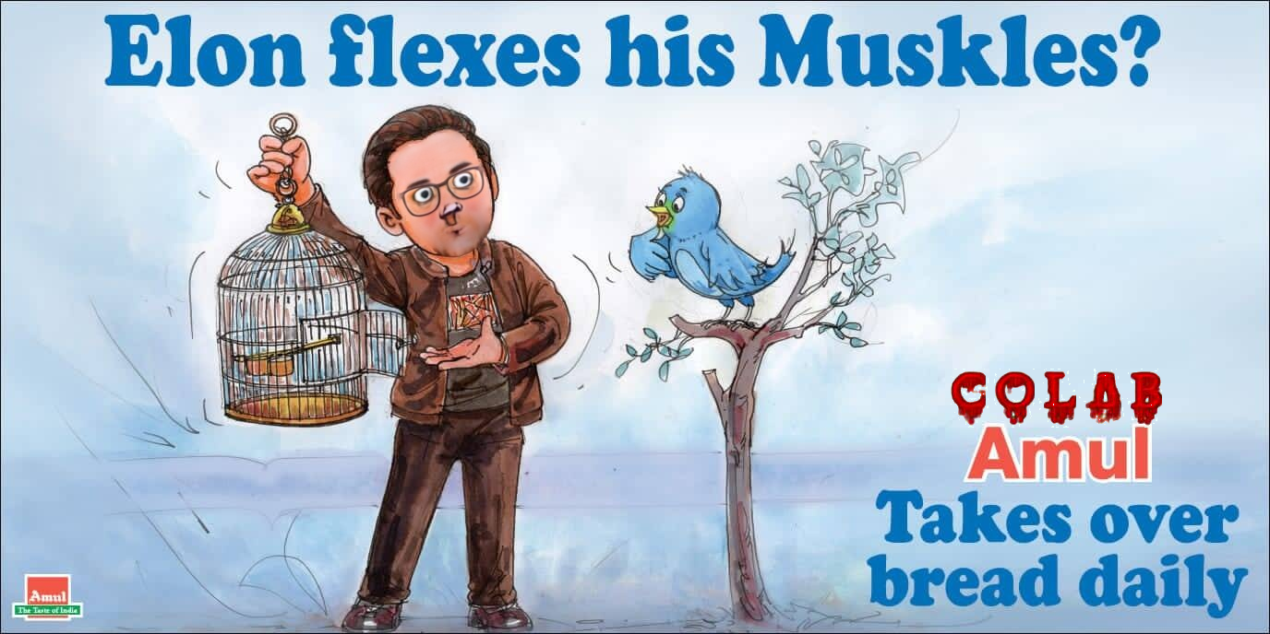

Now, need to create another pipeline:

* For extracting characters given a stylized text image (only capital letters):



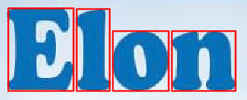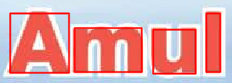





* Converting the characters into required format (content + shape + style):





* Finetuning the model with this new dataset: few_shot_size = 5, n_encode = 4
* Using the previous pipeline to generate any text with the same style:



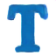









* Considering that we only use 2 capital letter (instead of the desired 5), the results are satisfactory.
* For the second style though, since we only had 1 capital letter, the results are

fail to capture the geometry, especially for the curvy letters. The capital letters in the few shot are getting captured well in both scenarios:

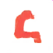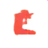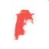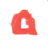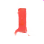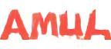

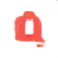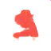





**Week 8**

* After string generation, :
  + Used *keras-ocr* which internally uses CRAFT to detect all texts and then Convolutional RNNs to recognize them. Also integrated this in place of the manual cutting and cropping of text in the font generation pipeline:

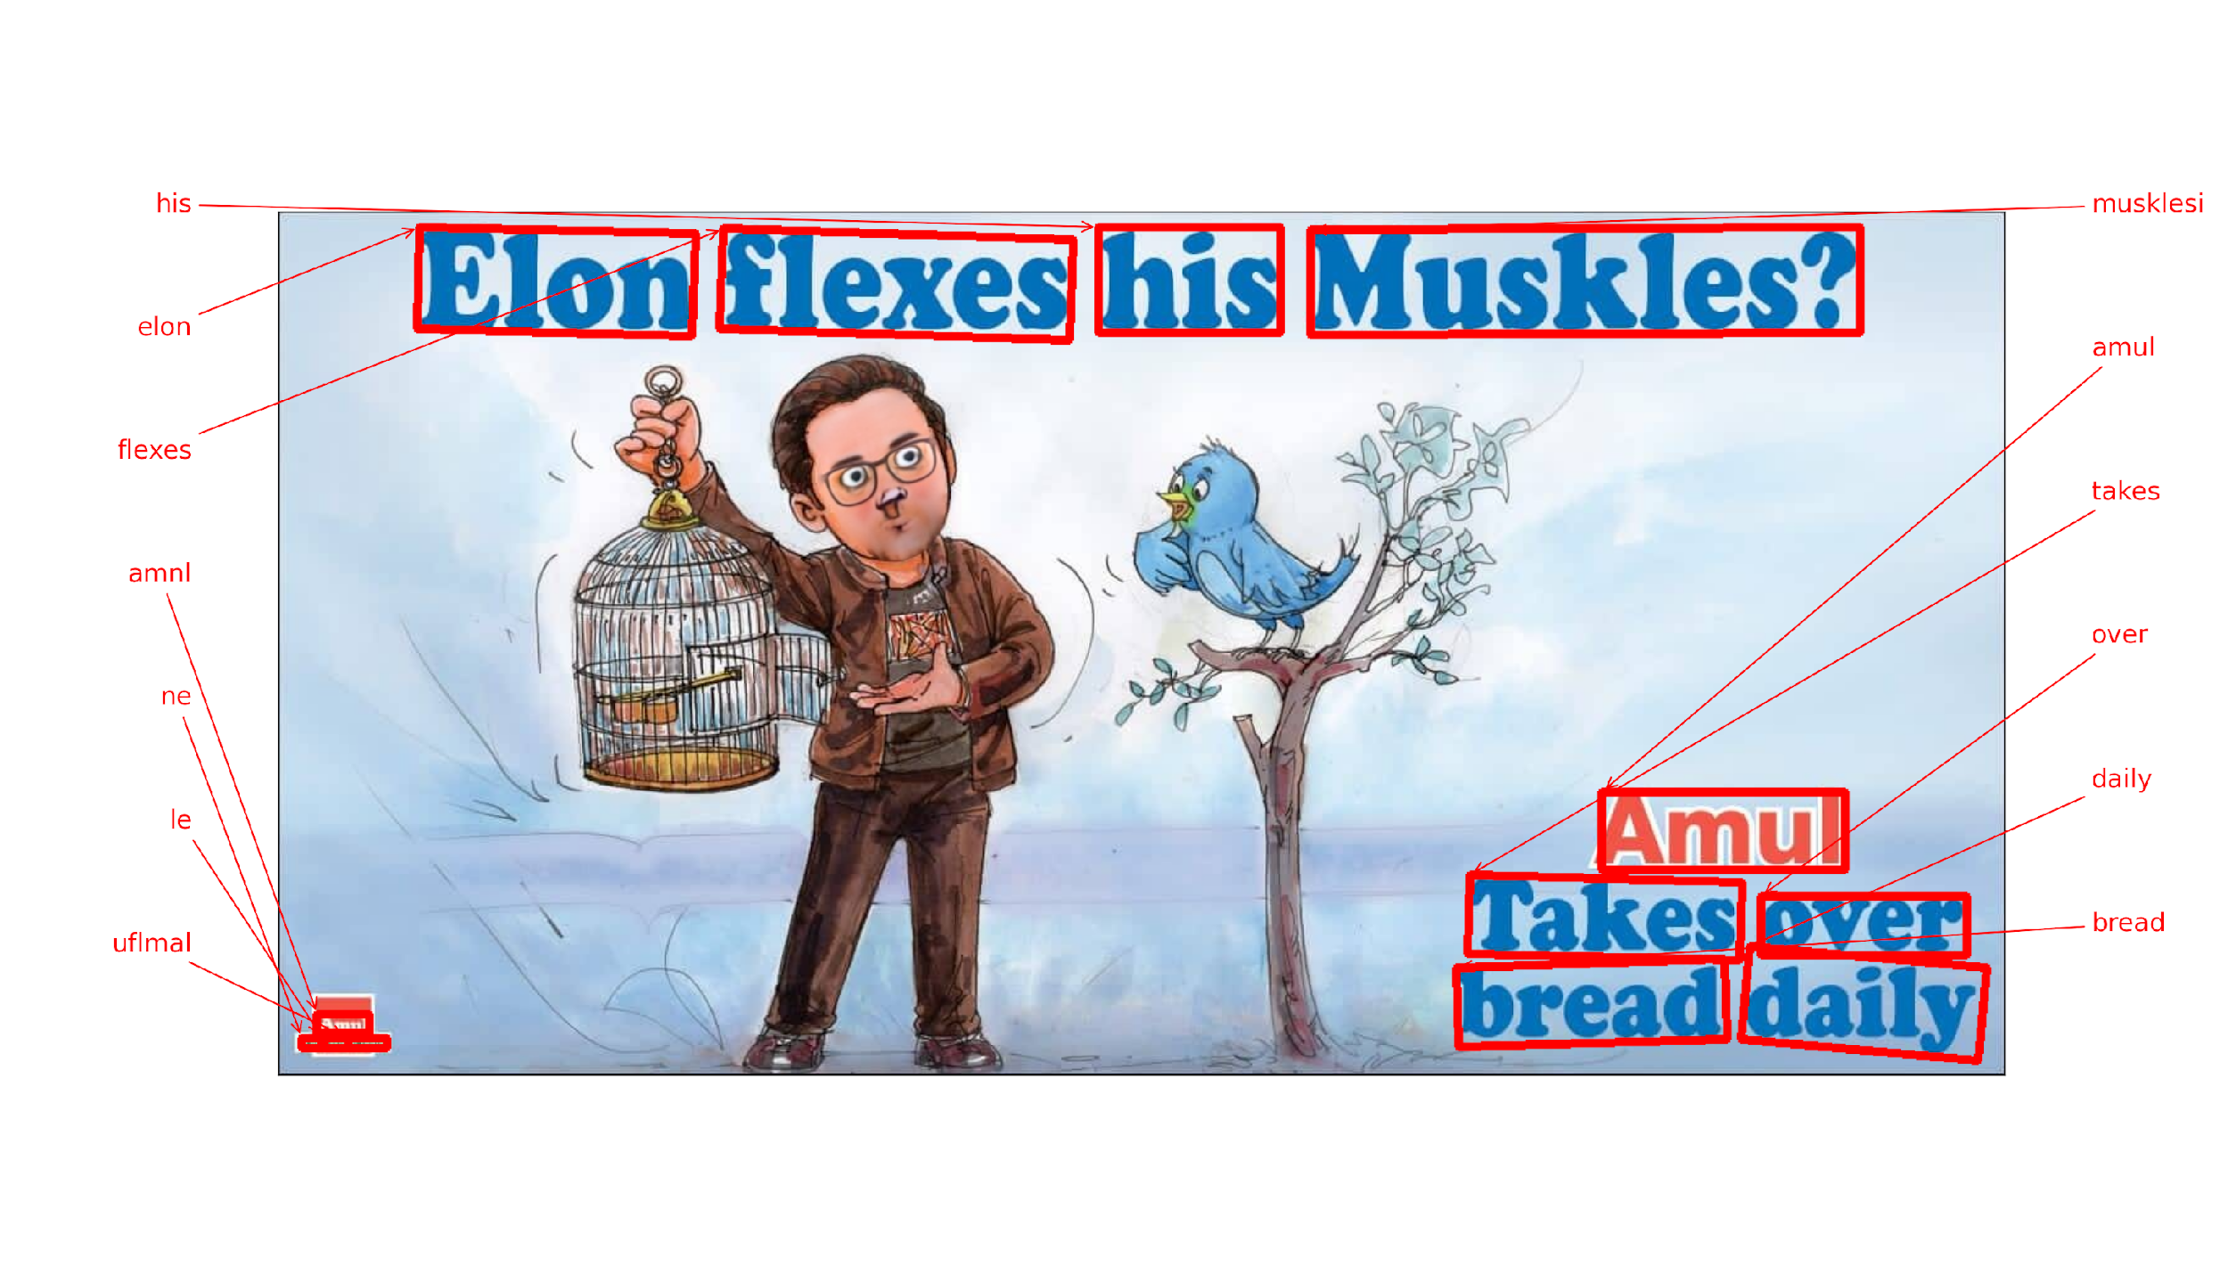

* + Removed the text using the bounding boxes as shown above. We can also selectively decide to keep or remove the text.
  + Then used OpenCV’s inpainting method fill in the empty parts. There are 2 inpainting methods in OpenCV. The deafult method’s result had boxy artifacts, so switched over to the second method:

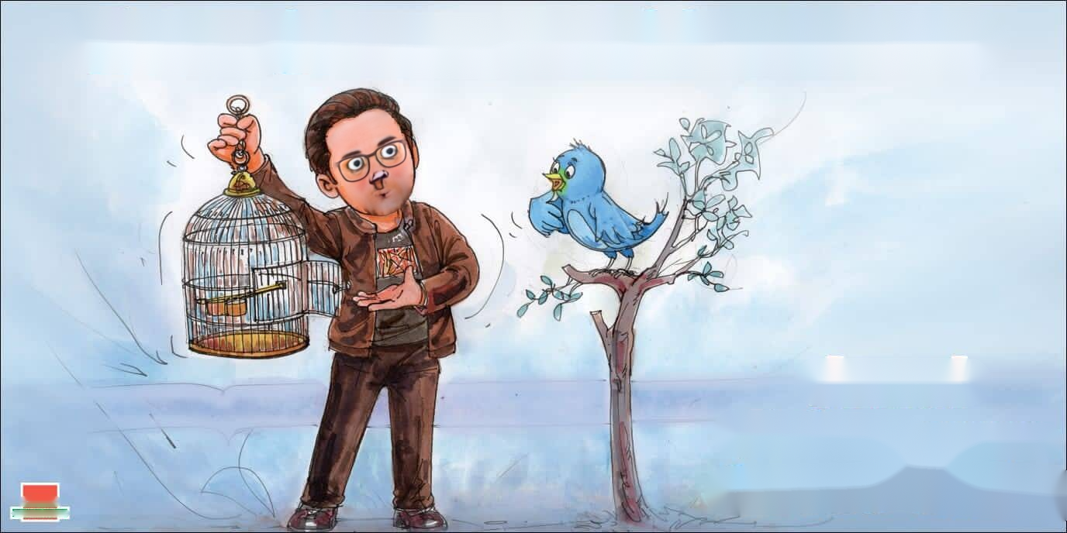

* + Finally, overlayed the string (after adding alpha channel and removing the background) into this new “textless” creative given coordinates of text and the scaling factor:
  + Breakdown of time taken per component: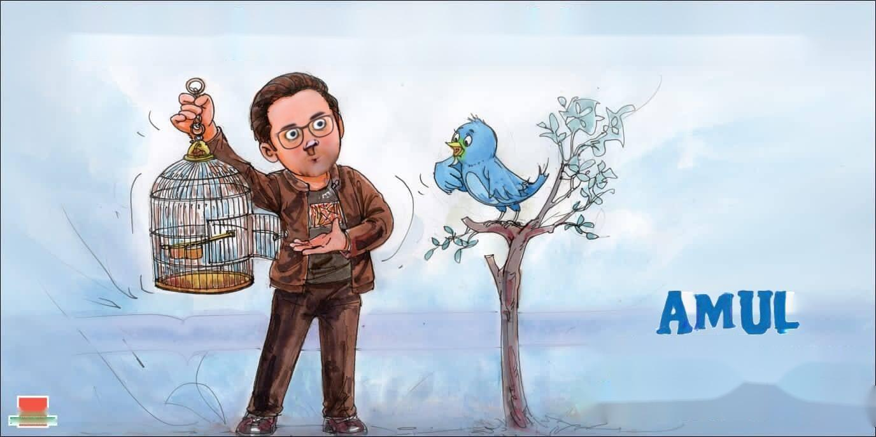
    - text detection + recognition: 9.408s
    - text removal + inpainting: 3.734s
    - string background removal + overlaying: 0.165s
    - total: 13.308s

What to do next:

* Replace faces with famous celebrities in another creative:

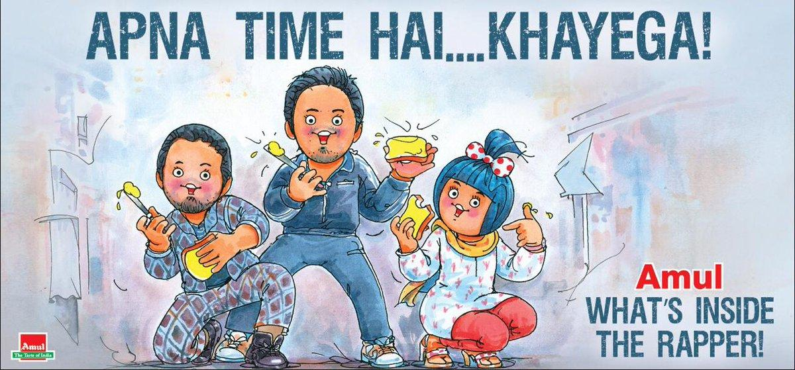

Seamless cloning:

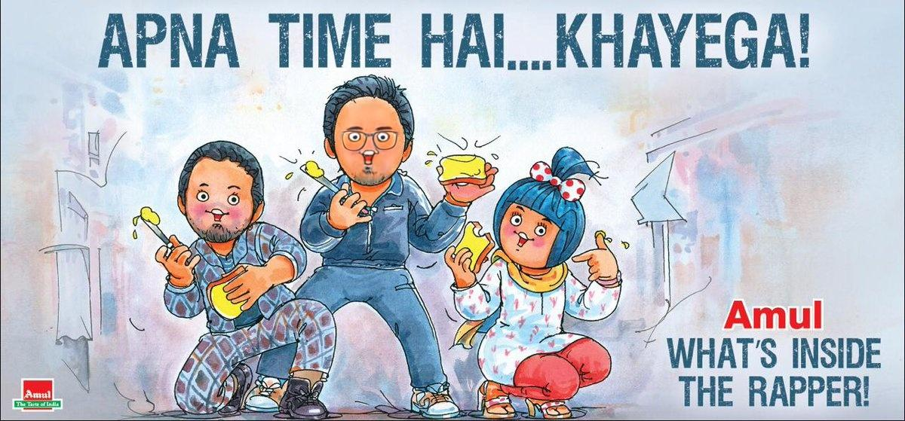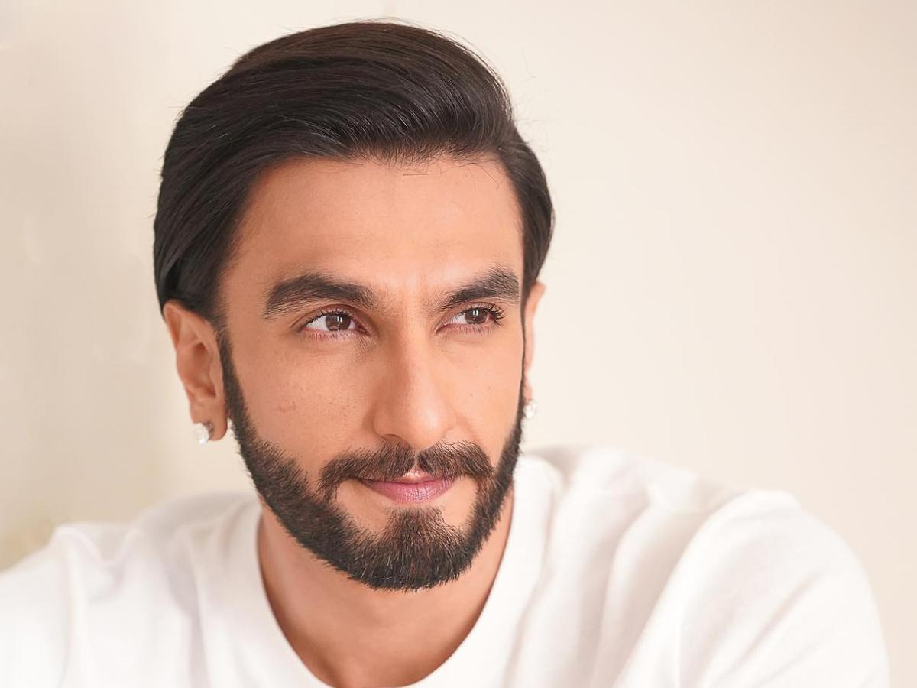

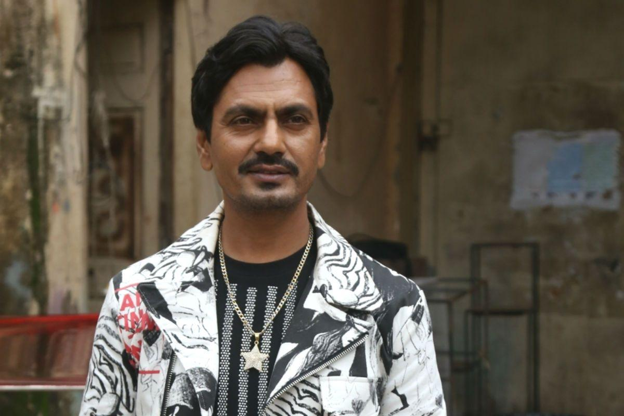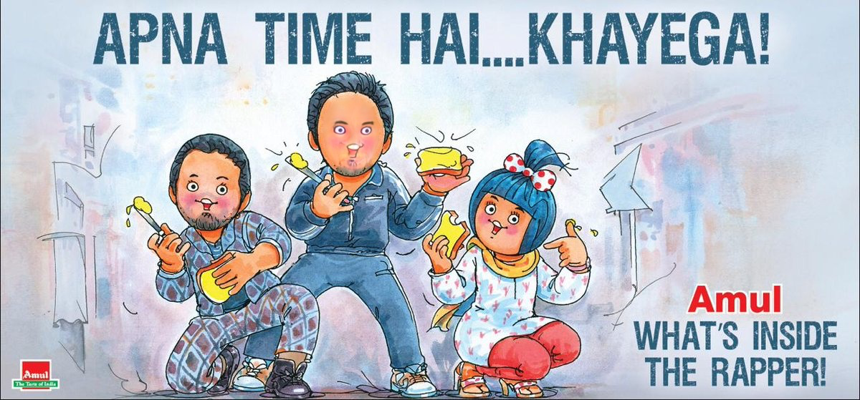

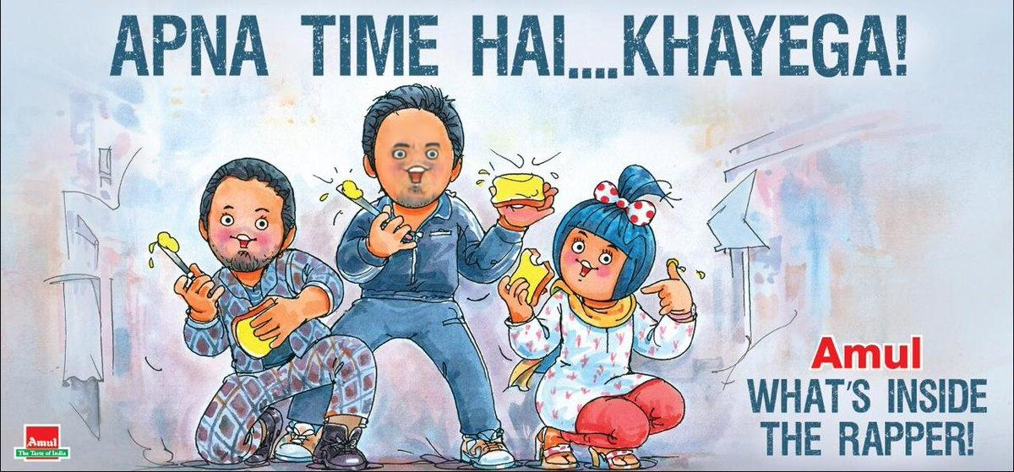

Inpainting + Insertion:

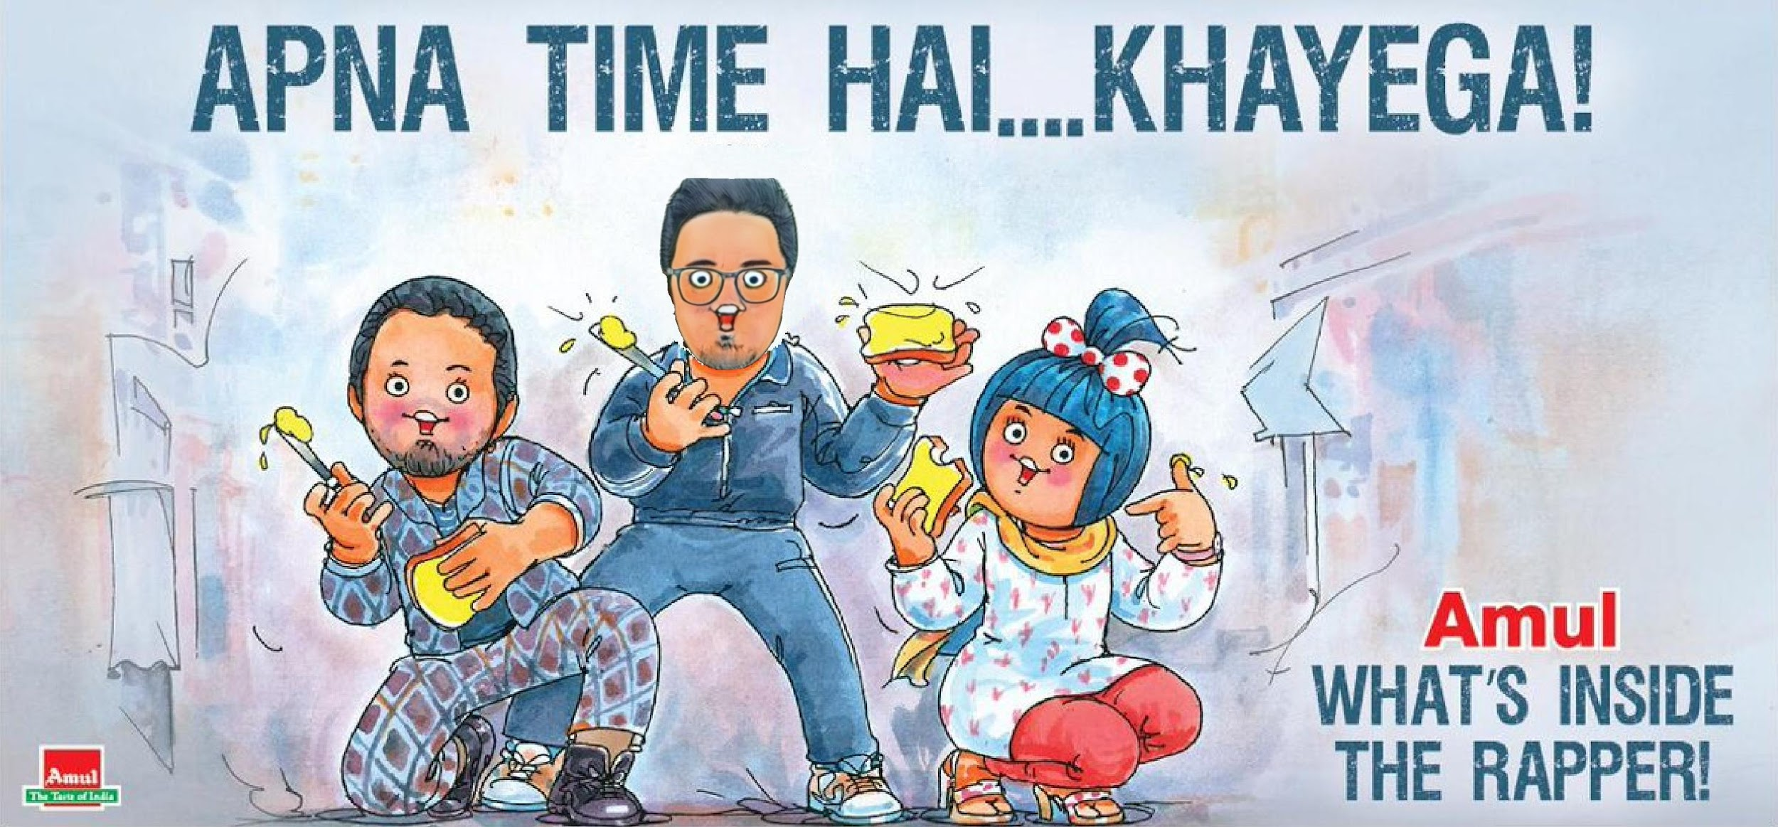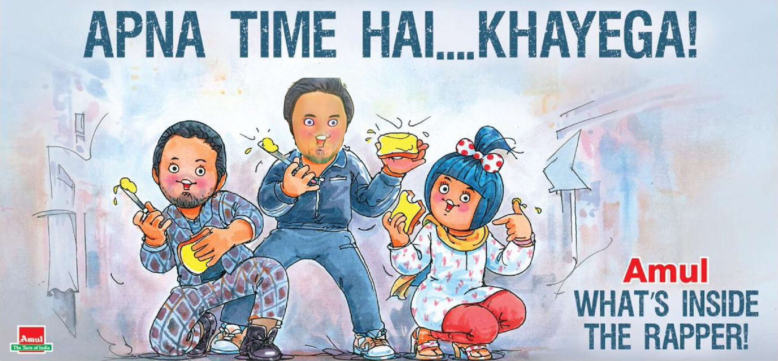

Blending with less style and more details preserved:

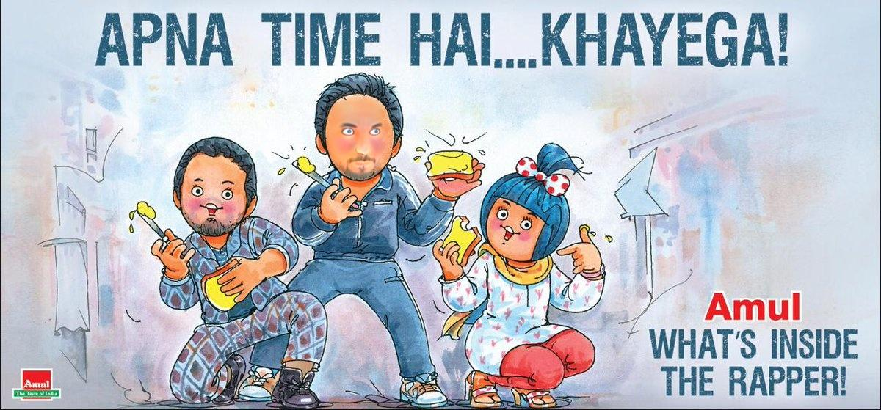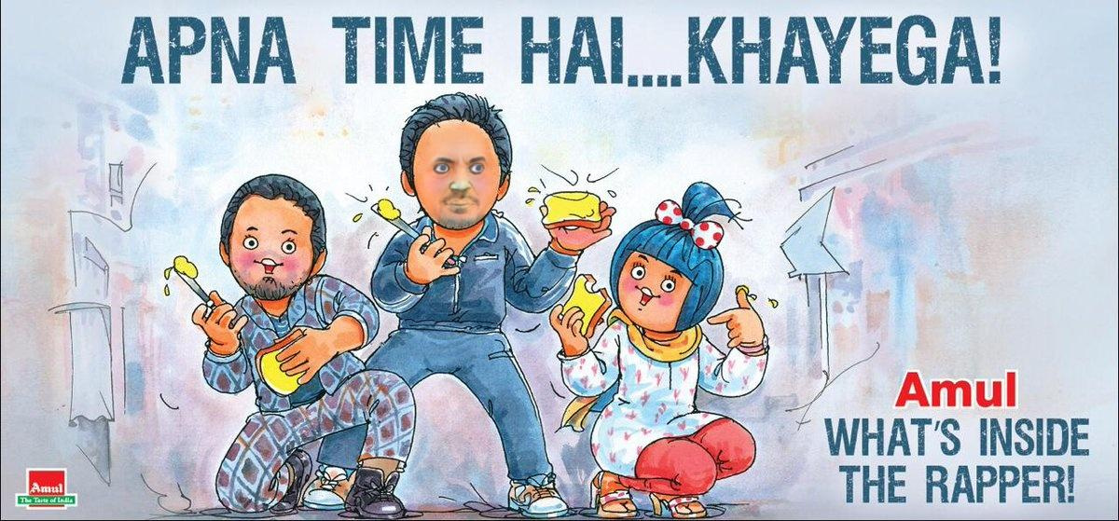

So we have 3 routes to go with face stylization + blending.

* In the same creative, transfer fonts from other brands like Britannia, Parle:
  + Font chosen:

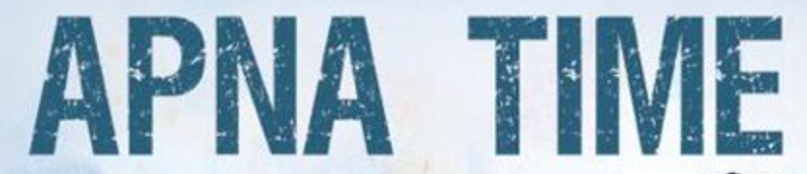

* + Characters chosen: A, N, P, M, E
  + Results:





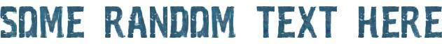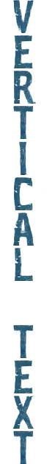

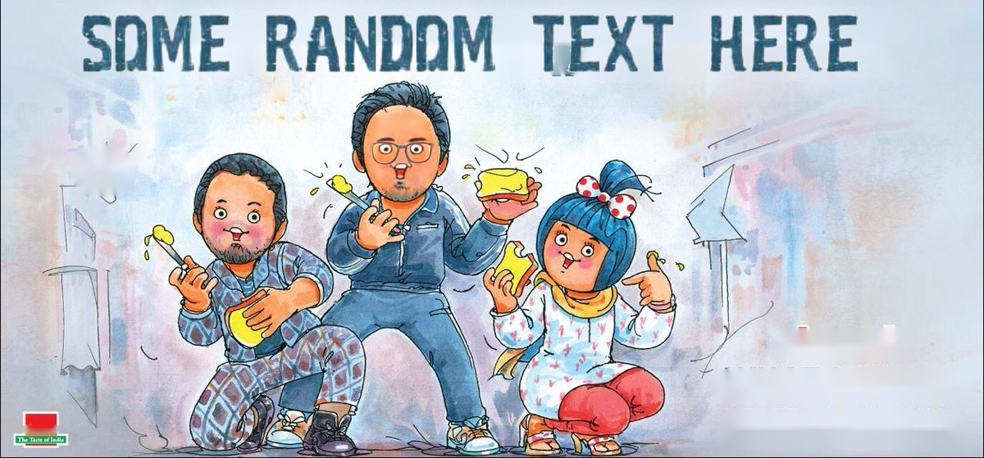

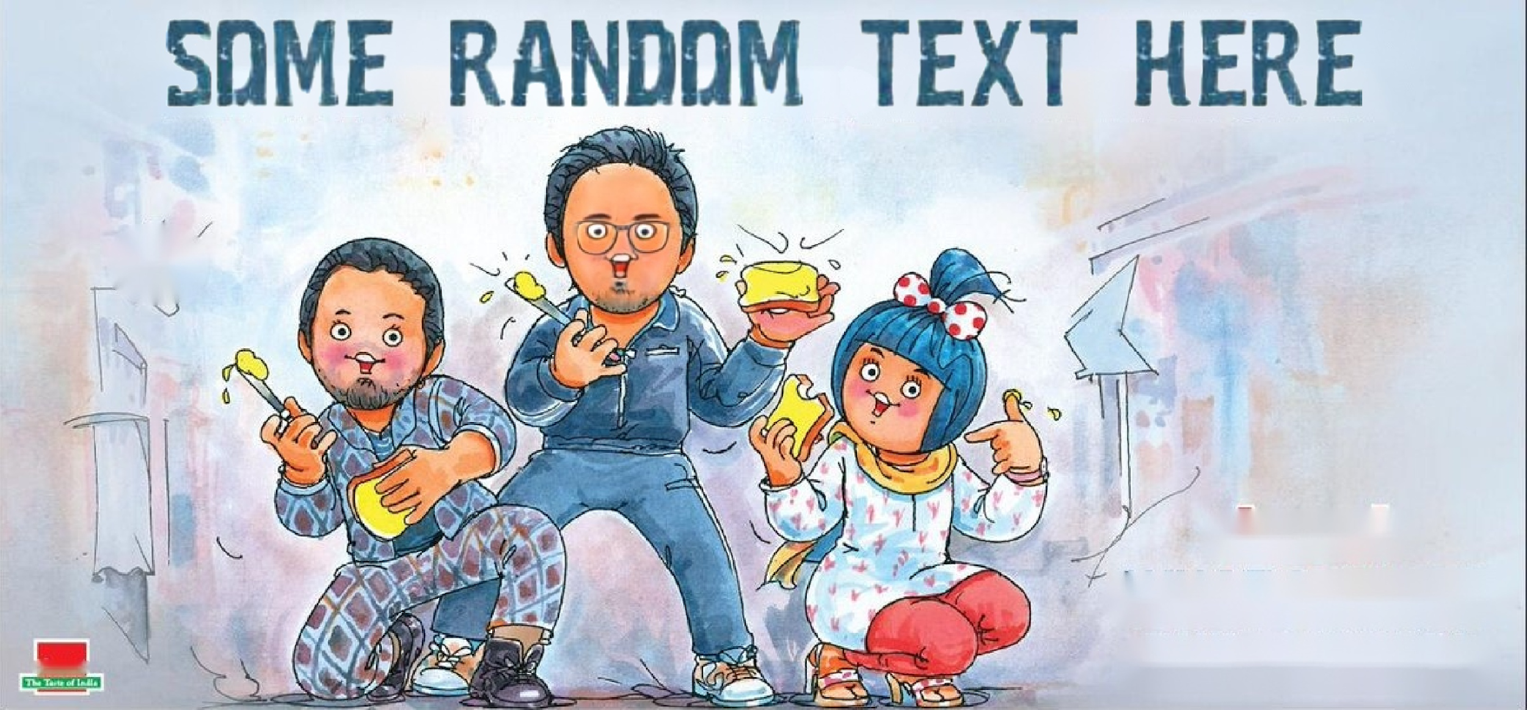

* + Font chosen:



* + Characters chosen: B, N, A, T, R
  + Results:



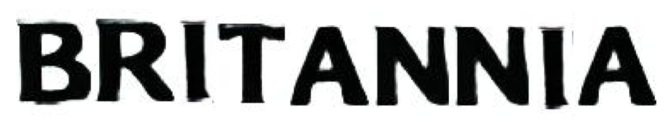

* + Font chosen:  
      
      
      
      
      
    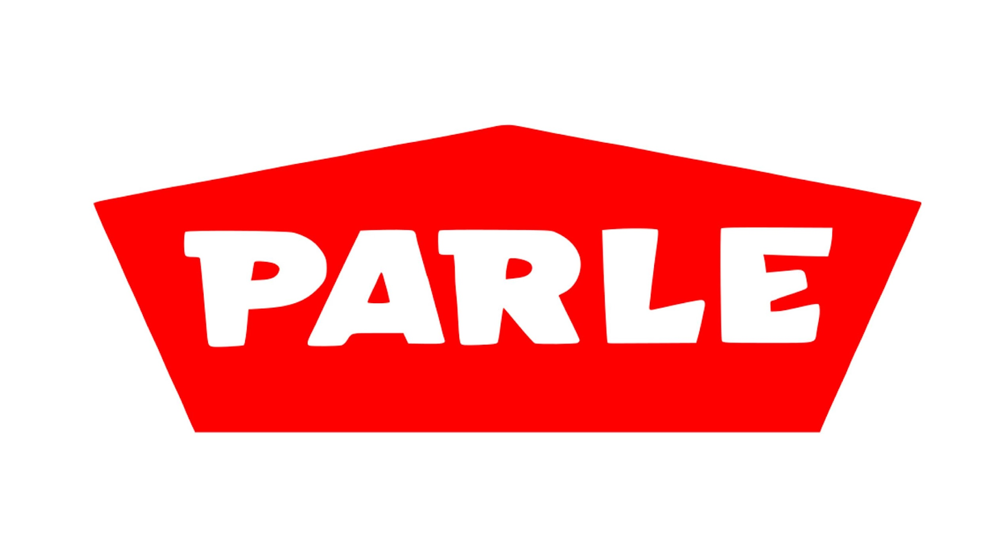
  + Characters chosen: P, A, R, L, E
  + Results:





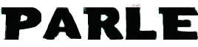

**Week 9**

Regarding font style transfer:

* We can train a StyleGAN2 model with the same font images used for AGIS-Net training. Then we can:
  + generate any random font.
  + given a character image, generate its style and apply it to any character using JoJoGAN’s training strategy.

Study on recent text-to-image models:

* Study about Imagen since it has the best FID score compared to other models like DALL-E 2. A great blog about Imagen: <https://www.assemblyai.com/blog/how-imagen-actually-works/>
* Diffusion model (DM) is used (slowly replacing GANs) which is a type of generative model that gives state-of-the-art performance on several tasks. Better than GANs since no adversarial training, no mode collapse.

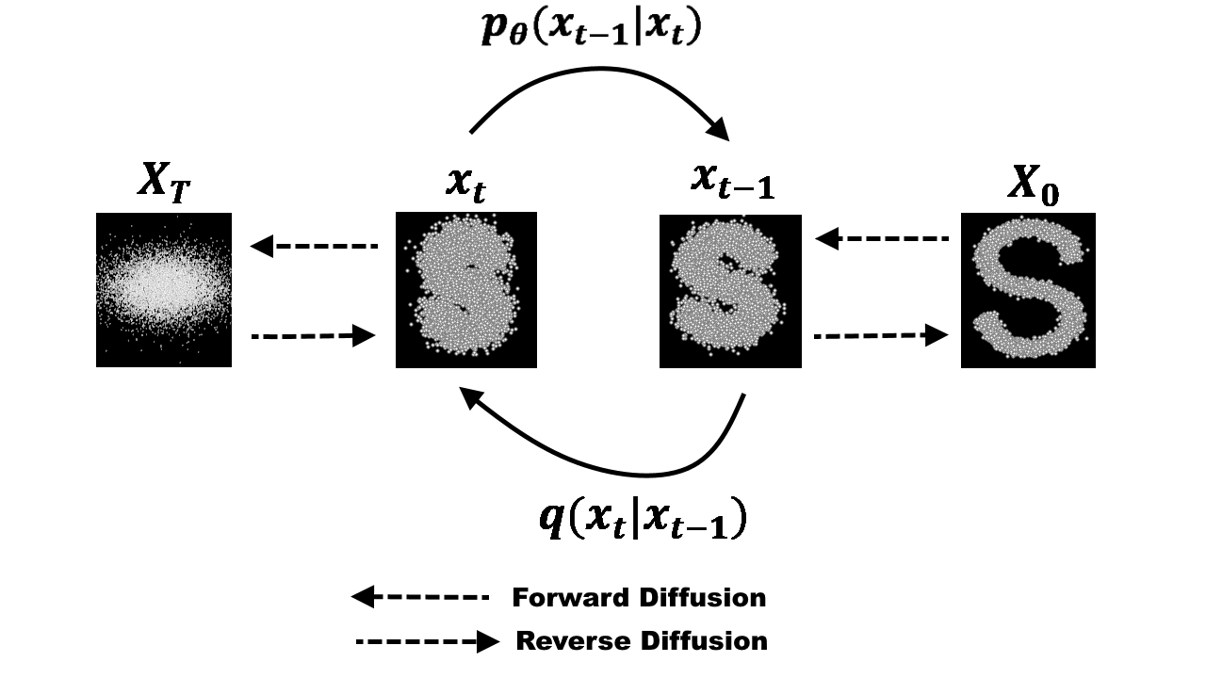

* DM is conditioned on the caption after passing the caption through a transformer encoder. The transformer’s weights are frozen during training. The output is a 64x64 image.
* This image is then upscaled by two super-resolution models which are also DMs. These DMs are conditioned on both – the generated image and the encoded caption. The final image is 1024x1024 image.